Pressure in fluids
Manometers measure a pressure difference by balancing the weight of a fluid column between the two pressures of interest.
Large pressure differences are measured with heavy fluids, such as mercury (e.g. 760 mm Hg = 1 atmosphere).
Small pressure differences, such as those experienced in experimental wind tunnels are measured by lighter fluids such as water (1 cm H₂O = 98.1 Pa).
To calculate the pressure indicated by the manometer
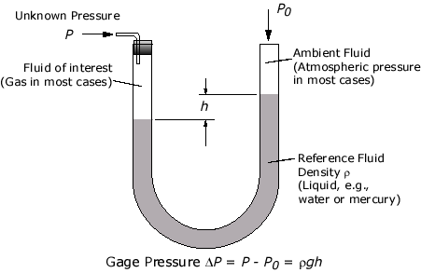

Po= Atmospheric pressure = 100,000Pa Approximately
- Using mercury density=14000kg/m3 calculate the pressure if

  - h=10cm

  - h =6cm

  - h=750mm

  - h=0.008m

- Using water density=1000kg/m3
  - h=2cm

  - h =10cm

  - h=750mm

  - h=0.0012m

Check your answers with this tool http://www.efunda.com/formulae/fluids/manometer.cfm#calc

- What is the height of a column of mercury when
  - P=100,000Pa

  - P=2750Pa

- Calculate pressures
P=100000 Pa
