Phase Changes
explain using a simple model for matter why
• melting and boiling take place without a change in temperature,
• the specific latent heat of vaporisation is higher than the specific latent heat of
fusion for the same substance,
• a cooling effect accompanies evaporation.

consider the bonding between molecules, changes in potential energy and in inetic energy of molecules.
The latent heat of fusion of ice

This experiment is designed to measure the amount of heat needed to turn 1 kg of ice at 0 ºC into 1 kg of water at 0 ºC

You will need
- electric immersion heater (12 V, 60 W)
- glass funnel (or plastic + aluminium foil)
- glass beaker
- joulemeter or 2 multimeters
- power supply (12 V ac, 6 A)
- stop clock
- retort stand, boss and clamp
- ice
- balance

12V ac
control
ICE
ICE
melted ice

What to do
Set up the apparatus as shown in the diagram but without the ice. One heater should be connected to the power supply. The other is a control that is set up at the front of the lab. Do not switch on yet. Weigh your beakers. Crush the ice and put the same in each funnel trying to pack it closely round the heater.
Start the stopwatch and at the same time switch on the heater, adjusting the voltage to about
12 V. Record the voltage (V) and the current (I).
Leave the heater on for three minutes, adding more ice if needed to keep some in contact with the heater.
Switch off, remove the beaker and weigh it.

Observations and calculations
Mass of beaker = kg
Mass of beaker + melted ice = kg
Mass of melted ice = kg
Mass of control beaker = kg
Mass of control beaker + melted ice = kg
Mass of control melted ice = kg
Mass of ice melted due the heater alone = kg
Heater power (VI) = W
Time = s
Energy input = Power x Time = J

This energy melted __________ kg of ice.
So ____________J would melt 1 kg of ice.

This is the specific latent heat of fusion of ice.

The amount of heat needed to change 1 kg of solid to 1 kg of liquid at its melting point is called the specific latent heat of fusion of the material

External reference
This activity is taken from Resourceful Physics

Heating and cooling curves
Stearic acid or lauric acid is heated beyond its melting point and then cooled.

You will need
- test tube
- test tube holder
- 15 g stearic acid or lauric acid (there are many suitable substances, see CLEAPSS Hazcard 46, Hydrocarbons (Aromatic))
- beakers (400 or 600 cm³)
- hotplate or careful use of a Bunsen burner
- 2 thermometers
- stop clock
- safety goggles
- graph paper
- paper towel
Alternative experiment
- temperature sensor and computer
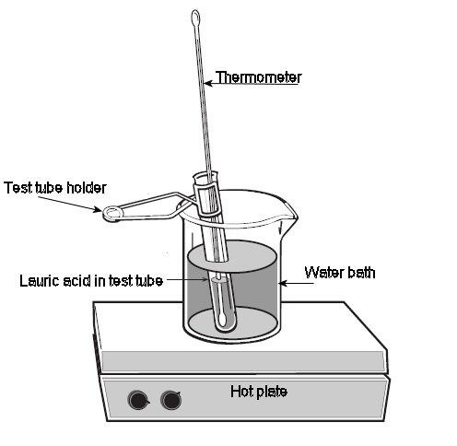
Method
Cooling curve
1. Fill one beaker about ⅔ full of warm tap water and place on the hot plate. Adjust the hot plate so that you can maintain the temperature of the water at about 75 ºC for stearic acid or 60 ºC for lauric acid
2. Fill the other beaker about ⅔ full of water from the tap and set aside.
3. Place the test tube of stearic acid or lauric acid in the hot water on the hot plate. As the acid starts to melt carefully put a thermometer in the test tube. Heat the lauric acid in the 60 ºC water until it is at about 55 ºC or the stearic acid to 75 ºC
4. Put the test tube of liquid stearic or lauric acid tube in the beaker of 30 ºC water and record the lauric acid temperature at 30-second intervals until the temperature reaches about 65 ºC if using stearic acid or 40 ºC for lauric acid. Gently stir with the thermometer as you take data until the acid starts to solidify. You have now completed the cooling curve data.

Heating Curve
1. Check that the water bath on the hotplate is still at the correct temperature. Adjust the hot plate if necessary and transfer the stearic or lauric acid tube with the thermometer back into the warm water.
2. Record the temperature of the stearic or lauric acid at 30-second intervals until the temperature reaches about 75 ºC (stearic acid), or 50 ºC (lauric acid). As soon as it is melted enough, stir the acid with the thermometer.
3. Now remove the thermometer from the acid and thoroughly wipe the acid off with a paper towel. Avoid getting any acid on your skin.

Questions
1. What is the melting point of your substance?
2. Explain what is happening in molecular terms for each region of the graphs.

Practical advice
This could be set up with a temperature sensor and computer so the graph is plotted automatically.
It is safer to use a hotplate but if a Bunsen is used it should be on a low flame.
Stearic acid, CH₃ (CH₂)16COOH can act as an eye, skin and respiratory irritant so the laboratory should be well ventilated. Melting point 69 - 70 ºC.
Lauric acid C₁₂H₂₄O₂ or (CH₃ (CH₂)₁₀COOH), is sometimes called dodecanoic acid or dodecoic acid is a white solid with a melting point of 44 - 46 ºC. It can act as an eye, skin and respiratory irritant so the laboratory should be well ventilated. In case of contact with eyes, rinse immediately with plenty of water and seek medical advice.
Naphthalene gives the best curve with sharpest points for onset and completion of solidification. It is rated Harmful but that is no worse than many other substances used in school science.
Safety
Avoid getting either acid on your skin. Wash off with water for 15 minutes if this occurs.
Questions involving specific heat capacity and specific latent heat

Data
Specific heat capacity of water = 4200 J kg⁻¹ K⁻¹.
Specific heat capacity of iron at 100 °C = 220 J kg⁻¹ K⁻¹.
Latent heat of vaporisation of water = 2260 kJ kg⁻¹.
Latent heat of fusion of water = 334 kJ kg⁻¹.
Density of ice at 0°C is 917 kg m⁻³.

1. Compare the energy needed to raise the temperature of 1kg of water from 20°C to 100°C and the energy needed to boil 1 kg of water at 100°C.
2. A 5kg block of iron is heated to 800°C. It is placed in a tub containing 2 litre of water at 15°C. Assuming all the water is brought to the boil rapidly; calculate the mass of water which boils off.
3. Sunlight of intensity 0.6 kW m⁻² falls on a patch of ice. Assuming the ice absorbs 20% of the light; calculate what thickness of ice would melt in 1 minute. (Assume any water produced runs off).

Further specific and latent heat questions

Data
Specific heat capacity of aluminium = 910 J kg⁻¹ K⁻¹.
Specific heat capacity of water = 4200 J kg⁻¹ K⁻¹
Specific latent heat of fusion of ice = 335 000 J kg⁻¹
Specific latent heat of evaporation of water 2.26 MJ kg⁻¹

1. How much heat energy is needed to heat 4 kg of aluminium by 8 ºC?
2. If 48 000 J of heat energy are given off when a 2 kg block of metal cools by 12 ºC, what is the specific heat capacity of the metal?
3. A 50 W heater is used to heat, an aluminium block with a mass of 5 kg. After 10 minutes the temperature of the block has risen by 4 ºC. Calculate:
(a) the heat given out by the heater;
(b) the specific heat capacity of aluminium.
(c) Why is your answer different from the correct value given in the data above?
4. How much heat energy is given out when 3 kg of water at 40 ºC cool to 25 ºC?
5. How much heat energy is given out when 500 g of steam at 100 ºC condenses and then cools to 50 ºC?
6. Why is a scald by steam at 100 ºC much more painful than one by water at 100 ºC?
7. How long will it take a 50 W heater to melt 2 kg of ice at 0 ºC?

