**AS Physics**

**Nuclear Physics**

**Question**

**booklet**

Name …………………………………………………………….

Mark /

Date due

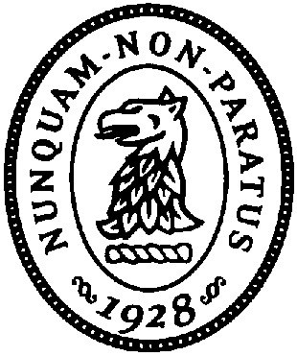

|  |  |
| --- | --- |
| Attempt **all** questions |  |
| Show **all** of your working |  |
| Write in Blue or black ink |  |
| Use a pencil **and** ruler for all diagrams and graphs |  |
| Make sure all answers include units |  |

You are expected to f

1. The numbers of protons, neutrons and nucleons in three nuclei are shown.



Which nuclei are isotopes of the same element?

**A** X and Y **B** X and Z **C** Y and Z **D** none of them

1. In an experiment to investigate the nature of the atom, a very thin gold film was bombarded with α-particles.

What pattern of deflection of the αparticles was observed?

**A** A few ↑-particles were deflected through angles greater than a right angle.

**B** All ↑-particles were deflected from their original path.

**C** Most ↑-particles were deflected through angles greater than a right angle.

**D** No ↑-particle was deflected through an angle greater than a right angle.

1. When a nucleus of 23892 U absorbs a slow neutron it subsequently emits two β-particles.

What is the resulting nucleus?

1. In what way do the atoms of the isotopes differ

**A** different charge

**B** different numbers of electrons

**C** different numbers of neutrons

**D** different numbers of protons





1. A nucleus of an atom of francium (Fr) contains 87 protons and 133 neutrons.
2. Write down the notation for this nuclide.

…………

Fr

………… [2]

1. The nucleus decays by the emission of an ↑-particle to become a nucleus of

astatine (At).

Write down a nuclear equation to represent this decay.

[2]

1. One isotope of iron may be represented by the symbol



1. State, for one nucleus of this isotope,

**(i)** the number of protons,

number = …………………………………….

**(ii)** the number of neutrons.

number = …………………………………….

[2]

**(b)** The nucleus of this isotope of iron may be assumed to be a sphere of radius

5.7  10–15m.

Calculate, for one such nucleus,

**(i)** the mass,

mass = …………………………………. kg

**(ii)** the density.

density = …………………………………. kgm–3

[4]

An iron ball is found to have a density of 7900 kgm–3.

1. By reference to your answer in **(b)(ii)**, suggest what can be inferred about the structure of an atom of iron.

.........................................................................................................................................

.........................................................................................................................................

.................................................................................................................................... [2]

