Linear motion

An experimental velocity-time graph
Aims
(c) find displacement from the area under a velocity-time graph
(d) use the slope of a displacement-time graph to find the velocity
(e) use the slope of a velocity-time graph to find the acceleration
(f) derive, from the definitions of velocity and acceleration, equations that represent uniformly accelerated motion in a straight line
(g) solve problems using equations that represent uniformly accelerated motion in a straight line, including the motion of bodies falling in a uniform gravitational field without air resistance
(h) recall that the weight of a body is equal to the product of its mass and the acceleration of freefall
(i) describe an experiment to determine the acceleration of free fall using a falling body

Deriving the equations of motion

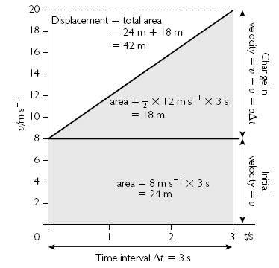

Look at the graph of motion with uniform acceleration. By finding the area under this graph we can derive another useful equation for uniformly accelerated motion – because the area under a velocity–time graph is equal to the displacement:

area of rectangle = initial velocity × time interval
area of rectangle = uΔt
area of triangle = ½ × base × height
area of triangle = ½ Δt × (v - u)

You know that:
(v – u) = a Δt

so area of triangle = ½ a Δt²

and displacement = area of rectangle + area of triangle

Δs = uΔt + ½ a Δt²

Usually you will see this equation written using just t (not Δt) to represent the overall time taken and s to represent the overall displacement:
s = ut + ½ at²

Use the equations that have you already met to show that:

v² = u² + 2as

Measuring the acceleration of free fall

Watch the demonstration
Diagram
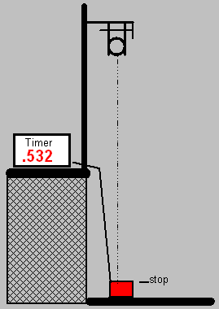
Add labels to the diagram.
Results
Displacement (s) /m | t1/s | t2/s | t3/s | tave/s | t² /s²

Analysis
Use the equation s =ut+0.5at² to calculate the acceleration due to gravity (g)
Show your working

In what ways is the method better than using a stop watch?

Motion under gravity
Questions 1-3 are about free fall. Use the approximation g = 10 m s⁻¹.
1) In the first part of a bungee jump, before the cord starts to stretch, the jumper is in free fall. Calculate the vertical displacement of a bungee jumper at 1.0 s, 2.0 s, 3.0 s, 4.0 s and 5.0 s after starting from rest.

2) Calculate the times taken for a bungee jumper to fall 1.25 m, 4 × 1.25 m, 9 × 1.25 m and 16 × 1.25 m from rest. Comment on your answers.

3) The diagram below shows a simple reaction timer. The idea is that, as the ruler is released, a buzzer sounds. At the sound of the buzzer, the person traps the ruler with their foot (rather like braking in a car). The distance that the ruler falls indicates the person’s reaction time.
Work out how the markings should be spaced if the timer is to be calibrated (marked) with times 0.1 s, 0.2 s, 0.3 s, etc.

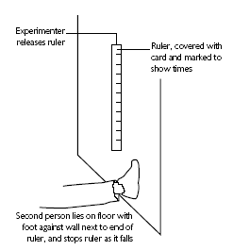
Thrust SSC
1. In 1997 Thrust SSC was driven to a supersonic world record speed of 771 mph (peak) and 767 mph (mile average) (about 334 m s⁻¹and 332 m s⁻¹).

Thrust SSC

In their research the Thrust SSC Development Team predicted that the car’s velocity would initially increase as shown in the graph below.
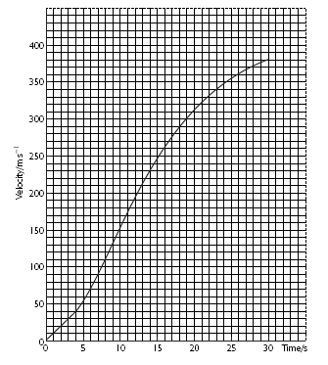
(a) Describe in words only (no numerical values) the predicted acceleration
(i) during the first 4 seconds,

(ii) from 4 s to 30 s.

(b) Use the graph to predict the size of the acceleration at 12 s.

(c) Use the same graph to predict the car’s displacement after 10 s.

