Questions on Newton’s third law

1. This question is adapted from the book ‘Thinking Physics is Gedanken Physics’ and is one of the most well known physics puzzles.

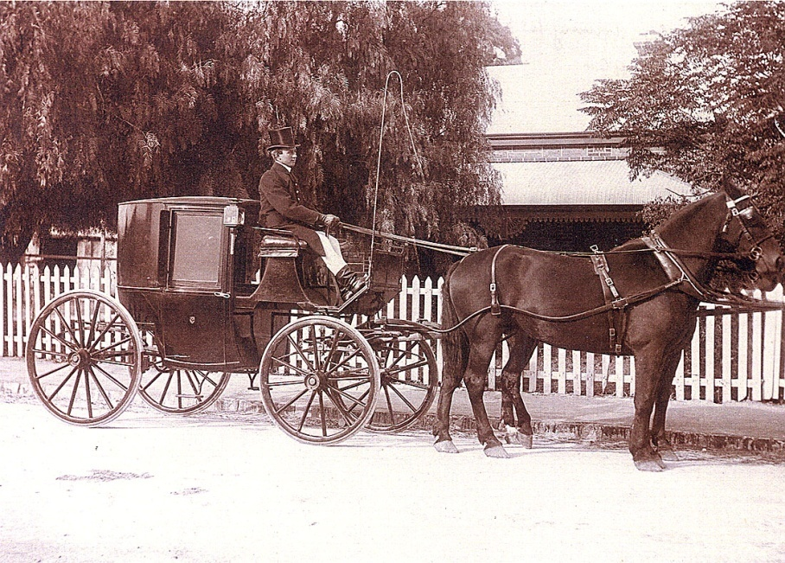
If the force on the carriage is equal and opposite to the force on the horse how can the horse pull the carriage? Is the answer:
(a) The horse cannot pull the carriage because the carriage pulls as hard on the horse as the horse pulls on the carriage.
(b) The carriage moves because the horse pulls slightly harder on the carriage
(c) The horse pulls the carriage before it has time to react.
(d) The horse can pull the carriage only if the horse is heavier than the carriage.
(e) Another explanation. What might it be?

2. A builder’s crane is a simple device that allows a person to haul himself/herself up using a pulley.

The builder has a mass of 75 kg and the cradle a mass of 35 kg. The builder pulls on the rope with a force of 650 N.
The rope will exert a force of 650 N upwards on the man and 650 N upwards on the cradle.
(a) Explain why the net upward force on the man is:

force exerted by the floor of the lift (F) – (weight of man – 650 N)

(b) Explain why the net force on the cradle is:

650N – weight of the lift – force man exerts on the cradle (F)

(c) Calculate the acceleration of the cradle and the force exerted by the man on the floor of the cradle. To do this you will have to use the two equations given in (a) and (b).
The net force in (a) is equal to mass of man x acceleration of man. The net force in (b) is equal to the mass of the cradle x acceleration of the cradle. As the acceleration of both man and cradle is the same you can solve these equations simultaneously.

