Learning Objectives:

At the end of this topic you will be able to;

- describe, by drawing a graph, the effect of a capacitor on the output waveform from a rectifier;
- know that the size of the ripple voltage is dependent on the method of rectification, the values of capacitance and load resistance;
- describe, by drawing graphs, the effect of loading on the output waveform of a smoothed rectifier.

Capacitive smoothing.

In our work on power supplies so far we have determined how to calculate the peak value of the output voltage from an rms value, and how to use half-wave and full-wave rectification methods to change a.c. into variable value d.c. The next stage is to smooth out the pulses of variable d.c. into a more regular output that might be suitable for use in electronic circuits.

The component needed to assist us with this stage of the process is the capacitor. You should remember that from Topic 2.2.1. the capacitor is a device that can store electrical charge. The addition of a capacitor to our rectifier circuits considerably alters the output observed on an oscilloscope as discussed in the following sections. The capacitor used in these applications is usually an electrolytic type with a very large capacitance value, typically ≥1000μF.

We will first look at the case of the half-wave rectified circuit, initially with no load resistor attached. For simplicity, the transformer has been replaced with a low voltage a.c. source.

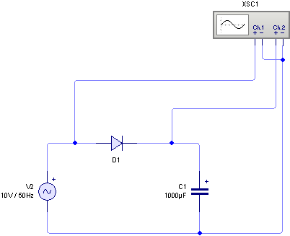

The resulting oscilloscope graph for this circuit is as follows:

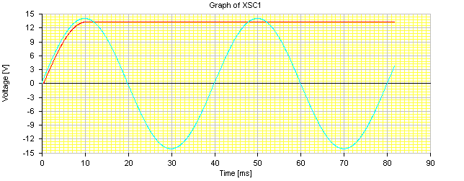

From the graph you can see that the output voltage shown in red holds its value at the maximum voltage, once the charge has built up on the capacitor during the initial charging cycle. As there is no load resistor applied to the circuit none of this charge comes off the capacitor and the voltage is maintained at it’s maximum value. It may appear that we have created our smooth d.c. supply, however this is only a false hope. Let us see what happens when a 100Ω load resistor is attached to the circuit. The circuit becomes:-

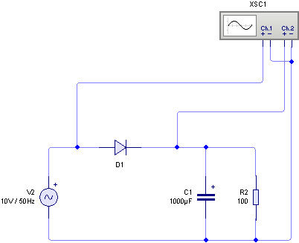
The resulting output voltage graph now becomes:
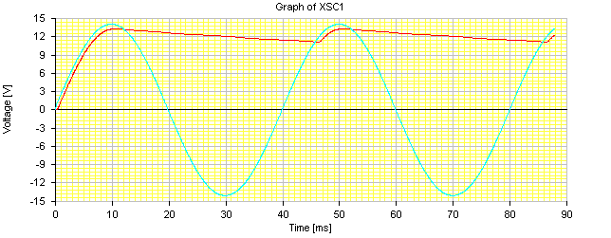
Ripple Voltage

Here we see that the output voltage falls slightly, as current is drawn by the load resistor. We see a drop until the input voltage increases again to top up the capacitor before the decay starts all over again. The difference between the highest and lowest output voltage is called the ripple voltage.

If the load resistor is decreased to 10Ω then the following output is obtained.
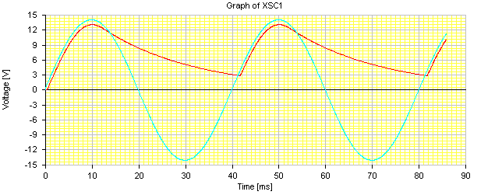
Ripple Voltage

Here the ripple voltage has increased significantly, and this highlights a major drawback of this simple system, particularly if the load resistance has a low value.
In these initial examples we have used half-wave rectification and the last example showed why this is an inefficient method to use as none of the energy in the negative half cycle is applied to the load resistor.

We can gain a big advantage if we switch the same smoothing capacitor and load circuit to a full-wave rectified supply as shown below, again shown here with an a.c. voltage source in place of the transformer.

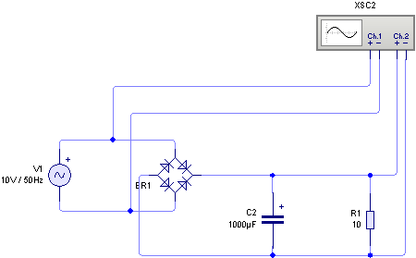
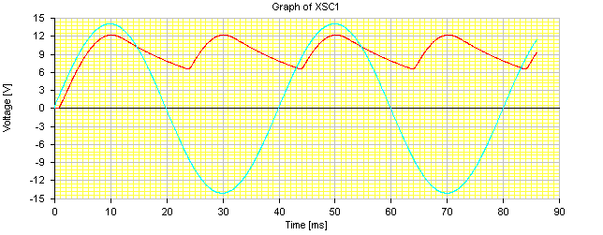
Ripple Voltage
The output voltage graph looks like this:

Here we can see three effects; (i) peak output voltage is lower due to extra diode voltage drop in bridge circuit. (ii) a smaller ripple voltage (actually halved) due to use of negative half cycle. (iii) the ripple frequency is doubled.
Hopefully from the work you have seen during the last few examples you will appreciate that the value of the ripple voltage will depend on a number of factors:

- the use of half-wave or full-wave rectification – half-wave rectification has a higher ripple value for the same smoothing capacitor and load resistor as only the positive half cycle is used. Full-wave rectification provides a lower ripple voltage as both positive and negative half cycles of the a.c. wave are used;
- the value of the smoothing capacitor – the higher the value of the capacitor the smaller the ripple voltage will be for a given load.
- The value of the load – The smaller the value of the load resistance the larger the current drawn from the supply, causing a larger ripple voltage.

You should experiment with changing these variables in a simulation package or on a breadboard with an oscilloscope to ensure that you are able to predict the response of a particular circuit.

In any examination question, you will not be asked to calculate the rate of fall of the voltage for a particular load, but you will be asked to sketch comparison graphs for different types of loads, for example no load, a small load, a large load etc. You could be asked to determine the size of the ripple voltage from graphs which have been given, and to describe how changing the size of smoothing capacitor, or load resistor would affect this ripple voltage.

In an ideal power supply the ripple voltage would be zero, so one measure of how good a power supply is would be to examine the ripple voltage and see how close it is to zero.

A basic power supply consists of three stages, (i) a transformer to reduce the mains voltage to a safe value, (ii) rectification to change a.c. into variable voltage d.c. and (iii) smoothing to reduce ripple even further. So let us put all of the last three sections together and try some exam questions on simple power supplies.
Examination Style Questions.

1. The following diagram shows a smoothed half-wave rectified power supply connected to a load.

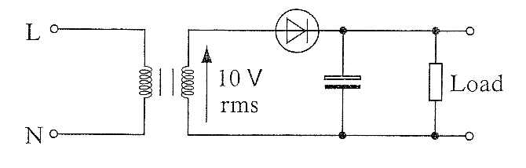

(a) The rms value of the secondary voltage is 10V. Calculate the peak value of

(i) the secondary voltage,

......................................................................................................................................

......................................................................................................................................
[1]
(ii) the voltage across the load.

......................................................................................................................................
[1]
(b) The following graph shows the voltage across the secondary windings.
On the same graph show the voltage across the load.

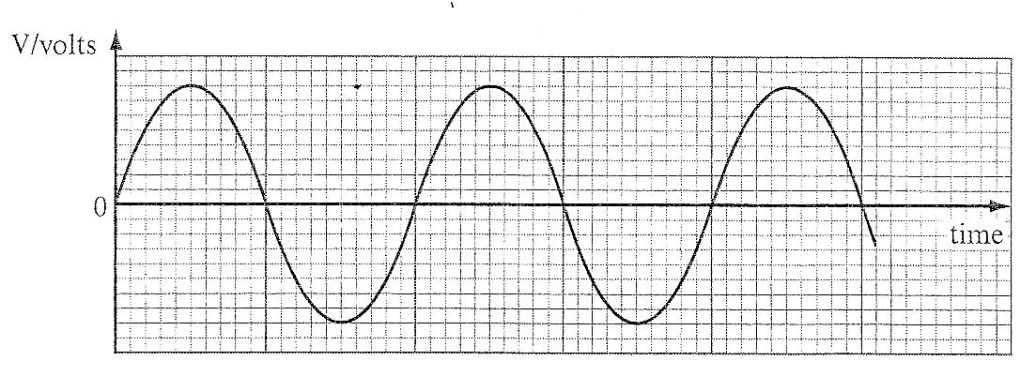
[2]
(c) Describe one advantage full-wave rectification has over half-wave rectification.

..................................................................................................................................................

..................................................................................................................................................

..................................................................................................................................................
[1]

2. The following diagram shows a smoothed half-wave rectified power supply.

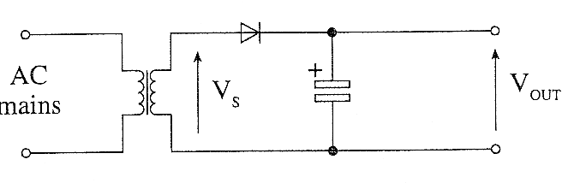
(a) The rms value of the secondary voltage V_{S} is 12V. Calculate the peak value of

(i) the secondary voltage V_{S},

..................................................................................................................................................

..................................................................................................................................................
[1]
(ii) the voltage V_{OUT}.

..................................................................................................................................................
[1]
(b) On the axes provided below, sketch a graph to show the output voltage V_{OUT} when

(i) there is no load connected,
(ii) a load that draws a significant current is connected to the output.

Label the axes with any relevant voltages.

The Voltage V_{S} is shown as a dotted waveform.
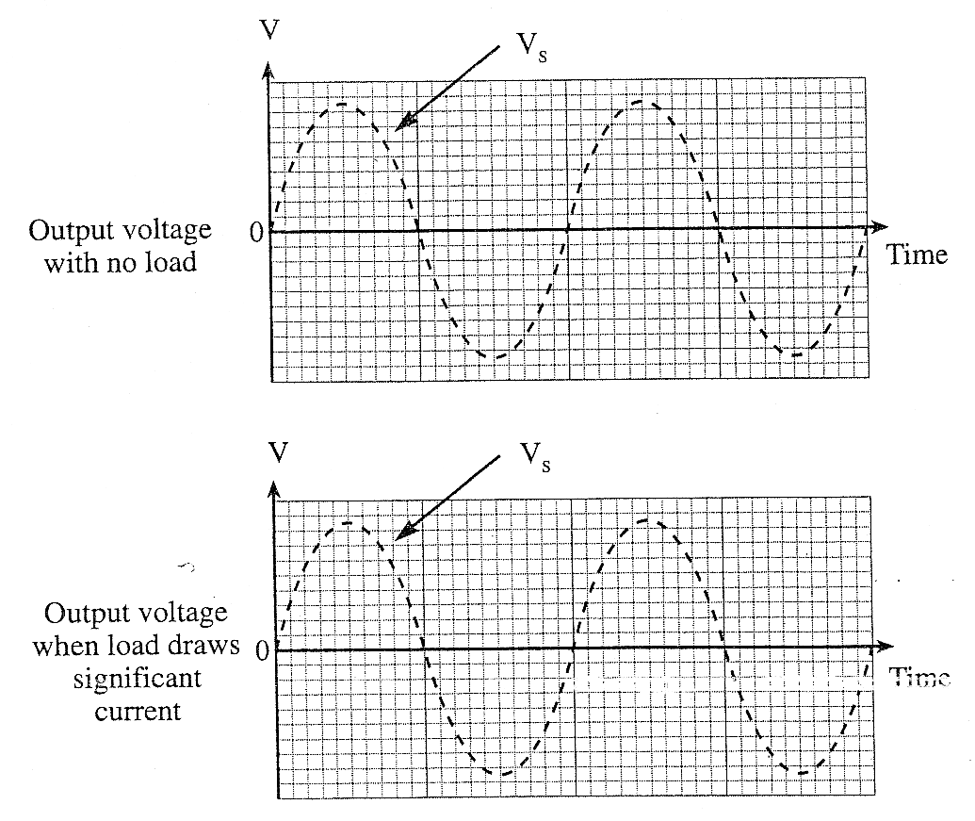
[3]
(c) (i) Explain by making reference to the graphs, what is meant by ripple voltage?

.................................................................................................................................................

.................................................................................................................................................

.................................................................................................................................................
[1]
(ii) Give two factors that contribute to the size of the ripple voltage.

First Factor ..................................................................................................................

Second Factor ..............................................................................................................
[2]

3. The following diagram shows a half-wave rectified power supply without a smoothing capacitor. The power supply is connected to a load that draws only a small current from it.

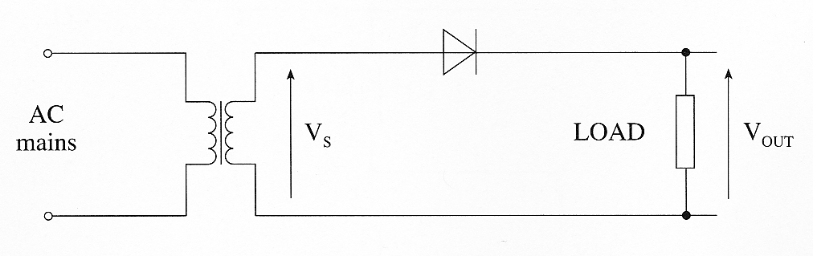

(a) The peak value of the secondary voltage V_{S} is 15V. Calculate:

(i) the rms value of the secondary voltage;

.................................................................................................................................................

.................................................................................................................................................
[1]
(ii) the peak value of the voltage V_{OUT}.

.................................................................................................................................................
[1]

(b) On the axes provided below, sketch a graph to show the voltage V_{OUT} when a small current flows through the load without a smoothing capacitor in the circuit.

Label the axes with any relevant voltages.

The voltage across the secondary windings of the transformer is shown as a dotted waveform.

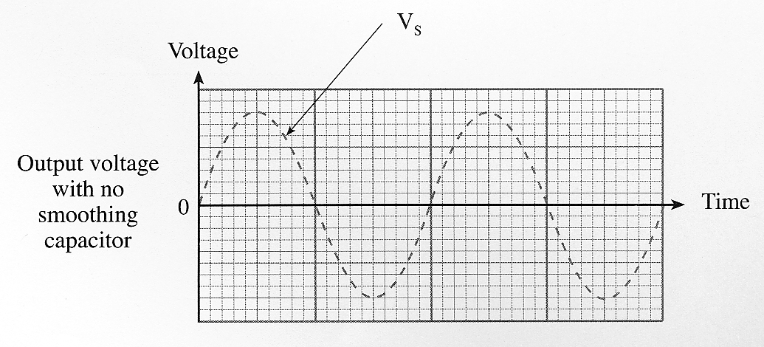
[2]

(c) (i) Add a smoothing capacitor to the circuit diagram.

(ii) Show the effect of the smoothing capacitor on the output voltage. Use the next set of axes to sketch V_{OUT} for this modified circuit when a small current flows through the load.

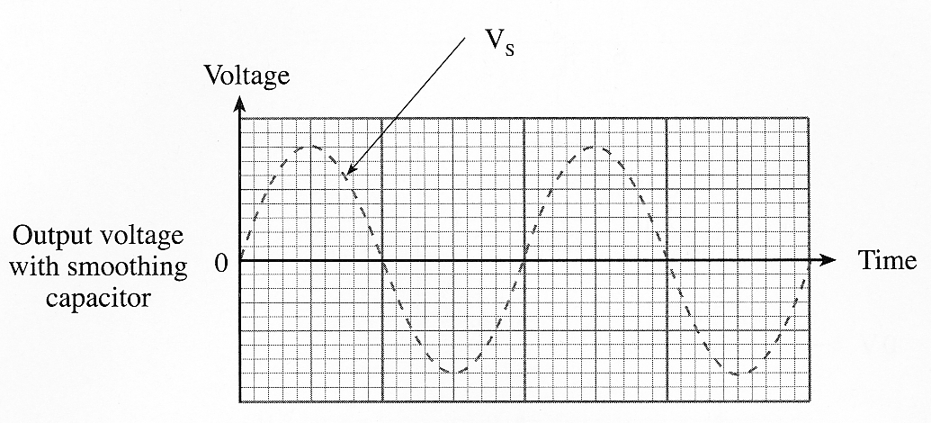
[2]

(d) The half-wave rectifier is replaced with a full-wave rectifier.

(i) What is the new peak value of the voltage V_{OUT}? ..................................
[1]
(ii) What happens to the frequency of the ripple voltage ?

...............................................................................................................................................
[1]
4. The following diagram shows a simple power supply.

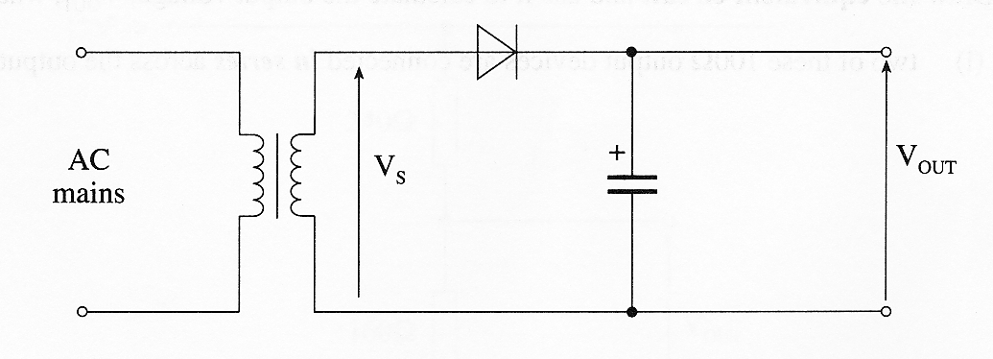

(a) the rms value of the secondary voltage V_{S} is 6V. Calculate the peak value of :

(i) the secondary voltage;

.................................................................................................................................................

.................................................................................................................................................
[1]
(ii) the voltage V_{OUT}.

.................................................................................................................................................
[1]
(b) On the axes provided below, sketch a graph to show the voltage V_{OUT} when

(i) there is no load connected,

(ii) a load that draws a large current is connected to the output.

Label the axes with any relevant voltages.

The voltage, V_{S}, across the secondary windings of the transformer is shown as a dotted waveform.

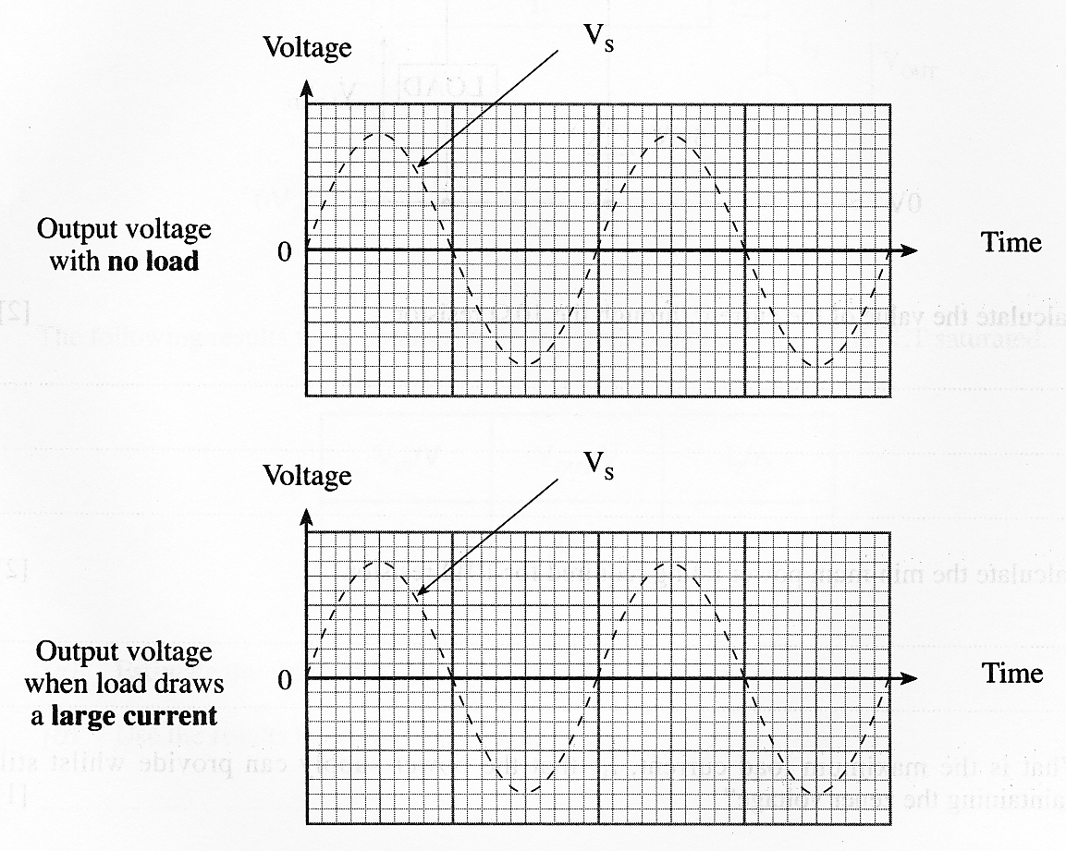

(c) (i) Explain by making reference to the graphs, what is meant by ripple voltage?

.................................................................................................................................................

.................................................................................................................................................

.................................................................................................................................................
[1]
(ii) Give two factors that contribute to the size of the ripple voltage.

First Factor ..................................................................................................................

Second Factor ..............................................................................................................
[2]
5. The following diagram shows part of a half-wave rectified power supply.

(a) Complete the circuit by adding:

(i) a diode to produce the half-wave rectification,

(ii) a capacitor to smooth the output.
[2]

(b) The rms value of the secondary voltage V_{S} is 20V. Calculate the peak value of

(i) the secondary voltage,

......................................................................................................................................

......................................................................................................................................

(ii) the voltage V_{OUT}.

......................................................................................................................................
[2]

(c) On the axes provided below, sketch the graph to show the voltage V_{OUT} when

(i) the load draws a small current,

(ii) the load draws a large current.

Label the axes with any relevant voltages.

The voltage across the secondary windings of the transformer is shown as a dotted waveform.

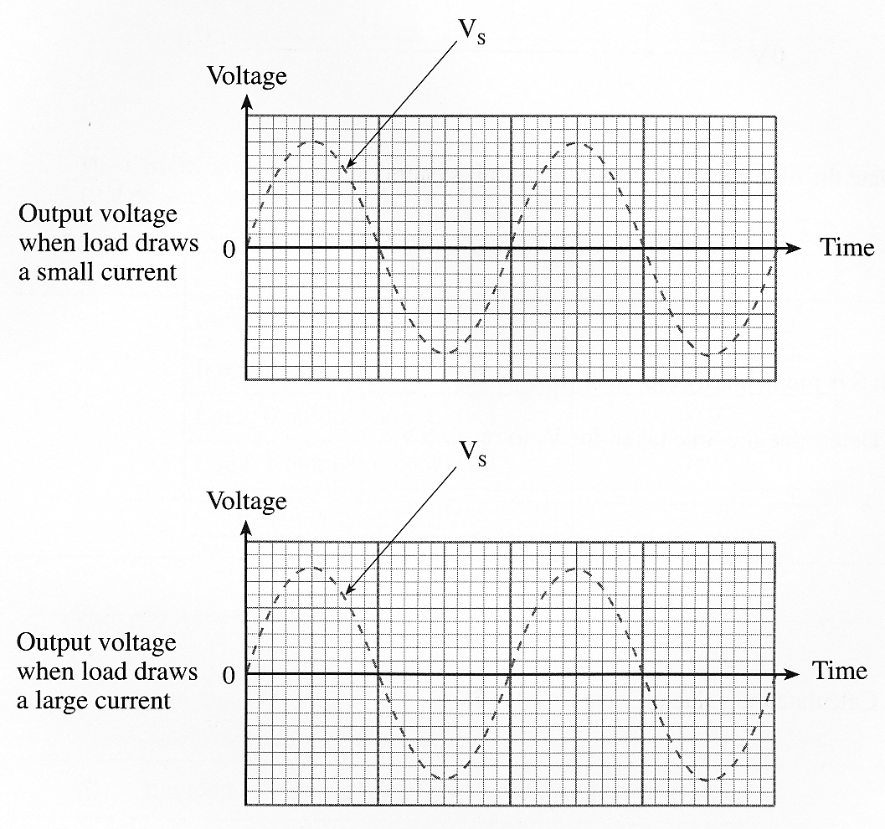
[3]

6. The following diagram shows a smoothed half-wave rectified power supply.

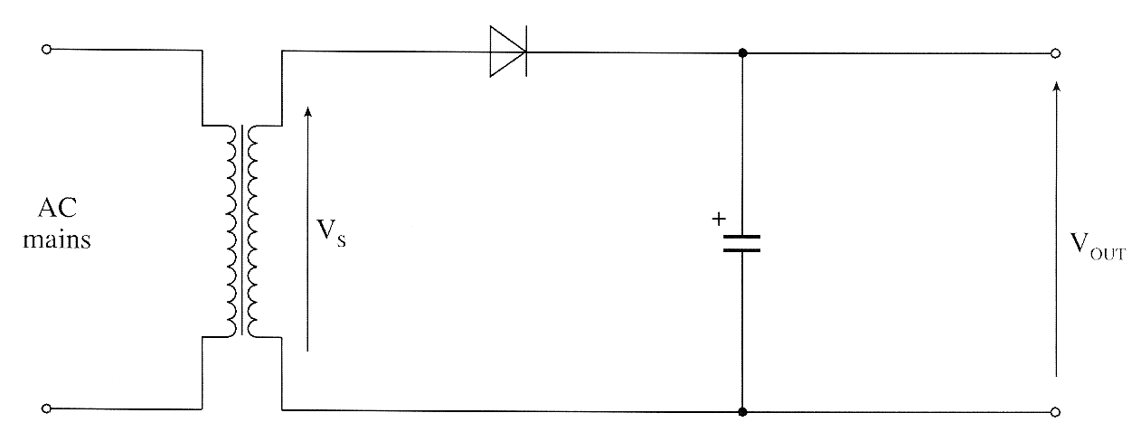

(a) The rms value of the secondary voltage, V_{S}, is 9V. Calculate the peak value of:

(i) the secondary voltage;

.................................................................................................................................................

.................................................................................................................................................
[1]
(ii) the voltage V_{OUT}.

.................................................................................................................................................
[1]

(b) On the axes provided below, sketch a graph to show the voltage V_{OUT} when

(i) there is no load connected,

(ii) a load that draws a large current is connected to the output.

Label the axes with any relevant voltages.

The voltage across the secondary windings of the transformer is shown as a dotted waveform.

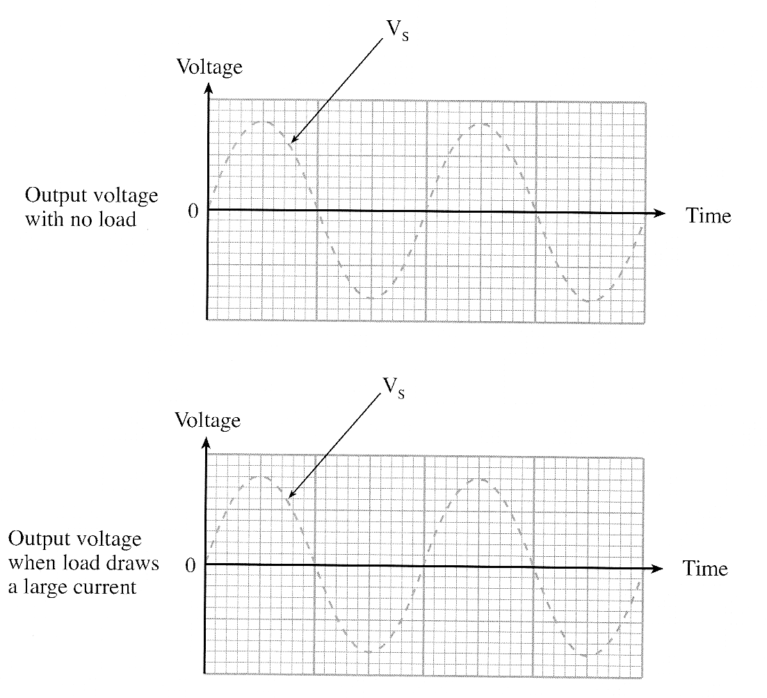
[2]
(d) The half-wave rectifier is replaced with a full-wave rectifier.

The mains frequency is 50 Hz. What is the frequency of the ripple voltage produced ?

..................................................................................................................................................
[1]

7. The following incomplete diagram shows a full-wave rectified power supply.

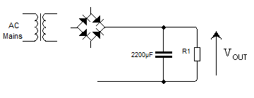

(a) Add the three missing connections [2]

(b) The peak value of the secondary voltage of the transformer is 16V. Calculate:

(i) the rms value of the secondary voltage;

.................................................................................................................................................

[1]
(ii) the peak value of the voltage V_{OUT}.

.................................................................................................................................................
[1]

(c) On the axes provided below, sketch a graph to show the voltage V_{OUT} when a significant current flows through the load resistor.

Label the axes with any relevant voltages.

The voltage across the secondary windings of the transformer is shown as a dotted waveform.

[2]

[2]

(d) The full-wave rectifier is replaced with a half-wave rectifier.

(i) What is the new peak value of the voltage V_{OUT}? ..................................
[1]
(ii) What happens to the frequency of the ripple voltage ?

...............................................................................................................................................
[1]

Self Evaluation Review

Learning Objectives | My personal review of these objectives:
describe, by drawing a graph, the effect of a capacitor on the output waveform from a rectifier.
know that the size of the ripple voltage is dependent on the method of rectification, the values of capacitance and load resistance.
describe, by drawing graphs, the effect of loading on the output waveform of a smoothed rectifier.

Targets: 1. ………………………………………………………………………………………………………………

………………………………………………………………………………………………………………

- ………………………………………………………………………………………………………………

………………………………………………………………………………………………………………

