# Forces and motion I

***• Describe the effects of forces on motion, including friction and air***

***resistance.***

***• Describe the effect of gravity on objects. Secondary sources can be***

***used.***

***• Calculate average speeds, including through the use of timing gates.***

***• Interpret simple distance/time graphs.***

**1.** The diagram shows four forces acting on a plane in flight.

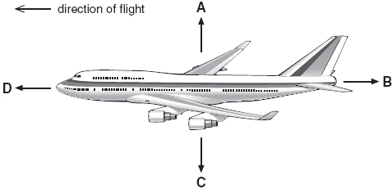

(a) Which arrow represents air resistance?  
Give the letter.

.............

1 mark

(b) (i) When the plane is flying at a constant height, which **two** forces must be balanced?  
Give the letters.

............. and .............

1 mark

(ii) When the plane is flying at a constant speed in the direction shown, which **two** forces must be balanced?  
Give the letters.

............. and .............

1 mark

(c) (i) Just before take-off, the plane is speeding up along the ground.

Which statement is true?  
Tick the correct box.

|  |  |
| --- | --- |
| Force B is zero. |  |
| Force B is greater than force D. |  |
| Force D is equal to force B. |  |
| Force D is greater than force B. |  |

1 mark

(ii) Which statement is true about the plane just as it leaves the ground?  
Tick the correct box.

|  |  |
| --- | --- |
| Force C is zero. |  |
| Force C is greater than force A. |  |
| Force A is equal to force C. |  |
| Force A is greater than force C. |  |

1 mark

maximum 5 marks

**Level 6**

**2.** Anil sits on a mat at the top of a helter-skelter and then slides down a chute around the outside.



(a) (i) Name **two** of the forces acting on Anil as he slides from point A to point B.

1. ....................................................................

2. ....................................................................

2 marks

(ii) As Anil slides from point A to point B, the forces acting on him are balanced.

Describe Anil's speed when the forces acting on him are balanced.

.............................................................................................................

1 mark

(b) Anil goes back for a second go. This time he sits on a smooth cushion instead of a mat.

He goes much faster on the cushion. Give the reason for this.

.....................................................................................................................

1 mark

(c) On his third go Anil lies back on the cushion with his arms by his side.

What happens to his speed? Give the reason for your answer.

.....................................................................................................................

.....................................................................................................................

.....................................................................................................................

2 marks

Maximum 6 marks

**Level 6**

**3.** The drawing below shows an astronaut in space.  
He has four small jets attached to his space suit.  
These jets produce forces on the **astronaut** in the directions A, B, C and D.

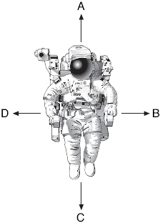

(a) The drawing below shows the size and direction of four forces acting  
on the astronaut.

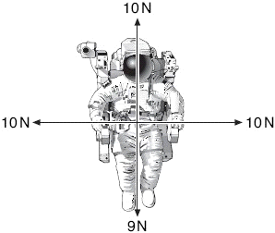

In which direction, A, B, C or D, will the astronaut move?

Give the letter.

..............

1 mark

(b) The drawing below shows the size and direction of four different  
forces acting on the astronaut.

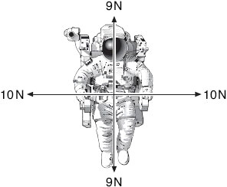

What will happen to the astronaut when the jets produce these four forces?

......................................................................................................................

1 mark

Explain your answer.

......................................................................................................................

......................................................................................................................

1 mark

(c) The drawing below shows the size and direction of four different  
forces acting on the astronaut.

Draw an arrow on the diagram below to show the direction in which he  
will move.

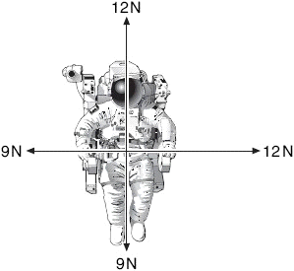

1 mark

maximum 4 marks

**level 6**

**4.** Russell investigated the relationship between mass and weight.  
He weighed five different masses using a force meter.

His results are shown in the table.

|  |  |
| --- | --- |
| **mass (g)** | **weight (N)** |
| 150 | 1.5 |
| 250 | 2.5 |
| 300 | 3.8 |
| 400 | 4.0 |
| 580 | 5.8 |

(a) He plotted four of his results on a grid as shown below,

(i) Plot the point for the 150 g mass on the graph.

1 mark

(ii) Draw a line of best fit.



1 mark

(b) One of the points Russell plotted does **not** fit the pattern.

Circle this point on the graph.

1 mark

(c) Use your graph to predict:

(i) the mass of an object weighing 6.5 N;

............. g

1 mark

(ii) the weight of an object of mass 50 g.

............. N

1 mark

(d) Give **one** reason why it is more useful to present the results as a line graph rather than a table.

.........................................................................................................................

.........................................................................................................................

1 mark

maximum 6 marks

**level 7**

**5.** The shuttle is a spacecraft which is used to take satellites into space.  
The drawing below shows the shuttle just about to take off.

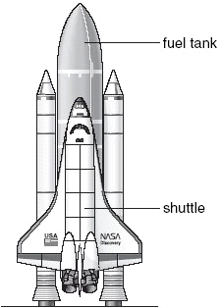

(a) The shuttle has a separate fuel tank containing liquid hydrogen and liquid oxygen.

Explain why hydrogen and oxygen are transported as liquids rather than as gases.

.........................................................................................................................

.........................................................................................................................

1 mark

(b) Oxygen is needed to burn the fuel in the shuttle’s engines.  
Vehicles on Earth do **not** need a tank containing oxygen.

Why does the shuttle need to have a tank containing oxygen?

.........................................................................................................................

.........................................................................................................................

1 mark

(c) The graph below shows how the upward force and the weight of the shuttle, including fuel, change during the first 20 seconds, after the fuel is ignited.



Why does the total weight of the shuttle **decrease** during the first 20 seconds?

.........................................................................................................................

.........................................................................................................................

1 mark

(d) (i) Look at the graph. At 20 seconds, what is the value of:

the upward force on the shuttle?

............. millions of N

the total weight of the shuttle and fuel?

............. millions of N

1 mark

(ii) At 20 seconds, what is the **resultant** force on the shuttle?

............. millions of N

1 mark

(iii) Use the graph to explain why the shuttle **cannot** take off before 10 seconds.

...............................................................................................................

...............................................................................................................

1 mark

maximum 6 marks

# Energy

***• Understand that energy cannot be created or destroyed and that***

***energy is always conserved.***

***• Recognise different energy types and energy transfers.***

# Energy Resources

***• Use knowledge of energy sources including fossil fuels and***

***renewable energy resources to consider the world’s energy needs,***

***including research from secondary sources.***

***• Identify and explain the thermal (heat) energy transfer processes of***

***conduction, convection and radiation.***

***• Explain cooling by evaporation.***

**1.** Luke investigated the heating of water. He predicted that the rise in temperature would depend on the volume of water.  
The diagram shows the apparatus he used.



Luke recorded his results in a table as shown below.

|  |  |  |  |
| --- | --- | --- | --- |
| **beaker** | **volume of water, in cm3** | **temperature at start, in °C** | **temperature after** **2 minutes, in °C** |
| A | 25 | 18 | 30 |
| B | 50 | 18 | 24 |
| C | 75 | 18 | 22 |

(a) Why did Luke need to know the temperature of the water at the beginning and at the end of the experiment?

.....................................................................................................................

.....................................................................................................................

1 mark

(b*)* Did Luke’s results support his prediction? Explain your answer.

.....................................................................................................................

.....................................................................................................................

1 mark

(c) Luke stirred the water during the experiment. How did this make his results more reliable?

.....................................................................................................................

.....................................................................................................................

1 mark

(d) Which of the following statements about the energy transferred to the beakers is correct?  
Tick the correct box.

|  |  |
| --- | --- |
| Much more energy went into beaker ‘A’ because its temperature increased the most. |  |
| The same amount of energy went into all three beakers. |  |
| Beaker ‘C’ received the most energy because there was more water to heat. |  |

1 mark

(e) After a time, all three beakers cooled down to room temperature.  
What happened to the thermal energy in the beakers as they cooled down?

.....................................................................................................................

.....................................................................................................................

1 mark

Maximum 5 marks

**Level 6**

**2.** The drawing below shows a garden water feature. It is solar-powered.

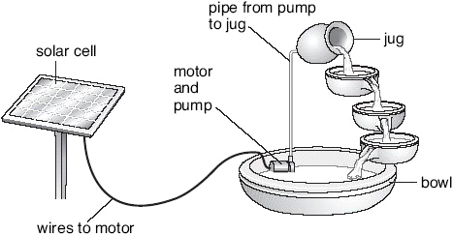

The solar cell absorbs energy from the Sun.  
The solar cell is connected to a motor in the bowl.  
The motor drives a pump.  
Water is pumped up to the jug and it flows back down to the bowl.

(a) Use the information above to help you to complete the following sentences.  
Choose words from the list.



(i) The useful energy change in the solar cell is from  
light to .................................... energy.

1 mark

(ii) The useful energy change in the motor is from  
electrical energy to .................................... energy.

1 mark

(iii) As the water flows from the jug to the bowl ....................................... energy is changed into .................................... energy.

2 marks

(b) Give **one** advantage and **one** disadvantage of using a solar cell to power the water feature.

advantage ...........................................................................................

.............................................................................................................

1 mark

disadvantage .......................................................................................

.............................................................................................................

1 mark

maximum 6 marks

**Level 6**

**3.** The photograph shows some pupils in a log car on a theme-park ride.

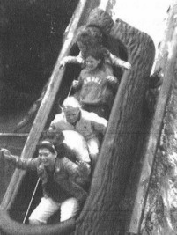

The drawing below shows the ride.  
The letters A, B, C, D, E and F show different points along the track.



The car starts from A and travels to F, where it stops by hitting a bumper.  
At E the car enters a trench filled with water.

(a) (i) At which **two** points does the car have **no** kinetic energy?  
Give the **two** correct letters.

............... and ...............

1 mark

(ii) At which point does the car have the **most** gravitational potential energy?  
Give the correct letter.

...............

1 mark

(iii) At which point does the car have **some** kinetic energy and the **least** gravitational potential energy?  
Give the correct letter.

...............

1 mark

(b) (i) The cars are **not** powered by a motor.  
What force causes the cars to move along the track from B to C?

...........................................................

1 mark

(ii) When a car splashes through the water at E, it slows down.  
What force acts on the car to slow it down?

...........................................................

1 mark

(c) Complete the sentence below by choosing from the following words.



When the car hits the bumper at F, its ................................... energy

is transferred into .............................. energy and

.............................. energy.

3 marks

maximum 8 marks

**Level 7**

**4.** Some pupils investigate whether double glazing or roof insulation is more efficient at reducing heat loss from houses.

They have a model house which can have these features:

• window with single glazing

• window with double glazing

• roof without insulation

• roof with insulation.



(a) A temperature sensor and a small lamp are placed inside the house. The lamp is used as a heat source.  
When the model house reaches a given temperature, **the lamp is switched off**.  
A datalogger then records temperature regularly over time.

(i) What can the combination of single glazing and **no** roof insulation tell pupils that is relevant to their investigation?

...............................................................................................................

...............................................................................................................

1 mark

(ii) Which **two** combinations **must** they use to find the more efficient way of preventing heat loss in their model house?

................................................... and ...................................................

................................................... and ...................................................

1 mark

(b) The pupils predicted that the roof insulation will be more effective than double glazing at reducing heat loss.

What evidence would support this prediction?

.........................................................................................................................

.........................................................................................................................

.........................................................................................................................

1 mark

(c) On the grid below, sketch the shape of the two graphs you would expect to see on the datalogger if the pupils’ prediction is correct.

You do **not** need to add scales to the axes.  
Use a solid line (_____) to show the graph for double glazed windows.  
Use a dotted line (-------) to show the graph for roof insulation.



2 marks

maximum 5 marks

**Level 7**

**5.** Keith has a wind-up radio.  
It does **not** use batteries. It is powered by a steel spring.

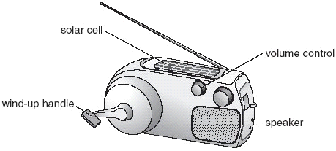

(a) Keith winds up the spring.  
As the spring unwinds, potential energy in the spring is transferred to a generator, which then turns.

The generator provides electrical energy for the radio.

Fill the gaps in the sentences below to show the useful energy changes which take place in the generator and the speaker.

(i) As the generator turns, ............................................................. energy is

changed to electrical energy.

1 mark

(ii) In the speaker, electrical energy is changed to

............................................................. energy.

1 mark

(b) When Keith turns the volume up so that the radio is louder, the spring  
unwinds more quickly.

Why does the spring unwind more quickly?

.........................................................................................................................

.........................................................................................................................

1 mark

(c) The radio has a solar cell which can also provide electrical energy.

Keith winds up his radio and takes it outside without changing the volume.  
The steel spring unwinds more slowly when sunlight falls on the solar cell. Explain why.

.........................................................................................................................

.........................................................................................................................

1 mark

(d) The wind-up radio was designed for use in poorer countries.

Suggest why wind-up radios are useful in poorer countries.

.........................................................................................................................

.........................................................................................................................

1 mark

maximum 5 marks

Complete the sentences by using the words below.

# The Earth and beyond

***• Describe how the movement of the Earth causes the apparent daily***

***and annual movement of the sun and the stars.***

***• Describe the relative position and movement of the planets and the***

***sun in the solar system.***

***• Discuss the impact of the ideas and discoveries of Copernicus,***

***Galileo and more recent scientists.***

***• Understand that the sun and other stars are sources of light and that***

***planets and other bodies are seen by reflected light.***

**1** The Earth is shaped like a ____________.

1. The Earth gets heat and light from the ____________.
2. The Earth spins on its ____________.
3. A day is the time it takes for one ____________.
4. There are 24 hours in one ____________.

**axis day sphere spin Sun**

# Look at the diagram

1. Colour the Sun yellow.
2. Colour the Earth blue.
3. Put a cross on the side of Earth that is in darkness.

##### Match up

year

satellite

orbit

leap year

The path that the Earth takes round the Sun.

The time taken for Earth to go around the Sun.

This goes around a plant. The Moon is the Earth’s …

When a day is added to every fourth year. This is

because an Earth year is 365.25 days long.

## 

## Moonshine

#### Name _____________________________ Class ___________

**1** The Moon reflects sunlight back towards the Earth.

Moon

Sun

Earth

a ) Colour the Sun yellow.

b ) Colour the half of Earth that is in daylight yellow.

c ) Colour yellow the half of the Moon that is lit by the sun.

d ) Draw a yellow arrow from the Sun to the Moon.

e ) Colour the arrow from the Moon yellow.

**2** Choose the correct answers.

a) When the Moon looks like a full circle, it is called

a full moon

a circle moon

b) When the Moon moves around Earth it takes

20 days

28 days

**3** TheMoon is between the Sun and the Earth.



The diagram shows a (lunar/solar) eclipse.

## Seasons

#### Name _____________________________ Class ___________

**1** Label the diagram using the words in the box.

summer

winter

sun

tilted

We have seasons because the Earths axis is .

**2** Label the Earth’s hemispheres.

northern hemisphere

southern hemisphere

**3** Choose the correct word

The Sun feels hotter in the summer because it is higher lower in the sky

more

less

and its rays are concentrated.

Summer days are also warmer than winter days because the sun is shining for

longer and has more less time to warm the air.

## Name _____________________________ Class ___________

S

u

n

° ° ° °

° °

° ° °

°

° °

° °

° °

° °

°

Mercury Venus Earth Mars Jupiter Saturn Uranus Neptune Pluto

**1** A solar system contains a star at the centre and other objects (orbiting/still) around the star.

### Tasks

Colour …

Mercury – purple

Venus – grey

Earth – green

Mars – red

Jupiter – brown

Saturn – orange

Uranus – pink

Neptune – dark blue

Pluto - blue

**3** Which planet is closest to the Sun?

_______________

**4** Which planet is the largest?

_______________

**5** Which planet is furthest away from the Sun?

_______________

**6** Which planet has the biggest rings?

_______________

**7** Which two planets are closest to the Earth?

_______________ and _______________

**8** Which is the only planet that has living things?

_______________

**2**

# Sound

***• Explain the properties of sound in terms of movement of air***

***particles.***

***• Recognise the link between loudness and amplitude, pitch and***

***frequency, using an oscilloscope.***

**1.** The dotar is a musical instrument with two strings.



(a) Aftal plays the dotar very quietly.

What must he do to the strings to make a louder sound?

.........................................................................................................................

.........................................................................................................................

1 mark

(b) Aftal makes the strings tighter so they vibrate more quickly.

How does this affect the sound produced by the strings?  
Tick the correct box.

|  |  |
| --- | --- |
| The sound has a lower pitch. |  |
| The sound is louder. |  |
| The sound has a higher pitch. |  |
| The sound is quieter. |  |

1 mark

(c) One of the strings is thicker than the other, so it vibrates more slowly.

In what way is the sound made by the thicker string different from the sound made by the thinner string?

.........................................................................................................................

1 mark

(d) Aftal played the dotar near a microphone connected to an oscilloscope.  
The diagrams below show the patterns made by four sounds.



(i) How does the sound shown in trace A differ from the sound in trace B?

...............................................................................................................

...............................................................................................................

1 mark

(ii) How does the sound shown in trace A differ from the sound in trace C?

...............................................................................................................

...............................................................................................................

1 mark

maximum 5 marks

**Level 6**

**2.** (a) Jacquie has a mobile phone. Energy is stored in the battery of the phone.  
The drawing shows the battery being charged.

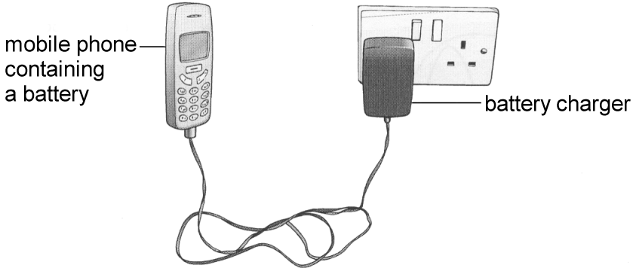

(i) Which energy transfer takes place in the battery as it is being charged? Tick the correct box.

chemical to sound  sound to thermal 

electrical to chemical  thermal to electrical 

1 mark

(ii) When the battery is fully charged, Jacquie unplugs the phone.

Which energy transfers take place when the mobile phone rings?   
Tick the correct box.

|  |  |
| --- | --- |
|  | chemical to electrical to sound  electrical to chemical to sound  kinetic to electrical to sound  thermal to electrical to sound |

1 mark

(b) Jacquie can change the ring-tone of her phone.  
The diagrams below show the patterns made by four sound waves on an oscilloscope screen.  
They are all drawn to the same scale.

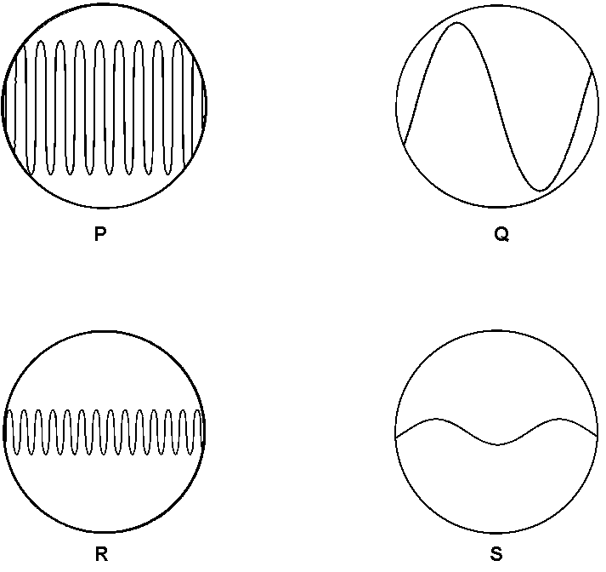

Write the letter of the sound wave that matches each of the descriptions below.

(i) a loud sound with a low pitch .................

(ii) a quiet sound with a high pitch .................

(iii) a loud sound with a high pitch .................

3 marks

Maximum 5 marks

**Level 6**

**3.** (a) (i) Air contains nitrogen.  
In the box below draw **five** circles, , to show the arrangement of particles in nitrogen gas.



1 mark

(ii) Zeena carries a personal emergency alarm.  
It uses nitrogen gas to produce a very loud sound.

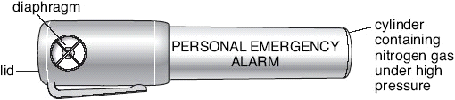

The nitrogen gas in the container is under much higher pressure than the nitrogen gas in the air.

How does the arrangement of nitrogen particles change when the gas is under higher pressure?

.............................................................................................................

.............................................................................................................

1 mark

(b) Use words from the boxes below to complete the sentence.



The rate at which the nitrogen particles hit the inside of the container is .................................... the rate at which nitrogen particles hit the outside of the container.

1 mark

(c) Zeena pushes the lid down and nitrogen gas escapes through the diaphragm.  
The diaphragm vibrates and produces a sound.

The pattern on the oscilloscope screen below represents the soundwave produced by the alarm.

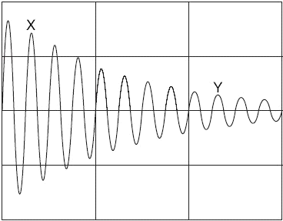

(i) The loudness of the sound produced by the alarm decreases between X and Y.

How can you tell this from the graph?

.............................................................................................................

.............................................................................................................

1 mark

(ii) The pitch of the sound produced by the alarm stays the same between X and Y.

How can you tell this from the graph?

.............................................................................................................

.............................................................................................................

1 mark

maximum 5 marks

**Level 7**

**4.** Three pupils took part in an investigation into the speed of sound.  
All three pupils stood 1020 m from an explosion.

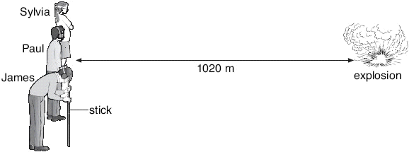

• Sylvia wore a blindfold.

• Paul wore ear defenders.

• James wore a blindfold **and** ear defenders. He rested his head on a wooden stick pushed into the ground so that he could feel vibrations.

The explosion produced sound and light at the same time.  
The table shows the speed of sound in two different materials.

|  |  |
| --- | --- |
| **material** | **Speed of sound (m/s)** |
| air | 340 |
| soil | 3200 |

(a) Use all the information above to help you answer parts (i) and (ii) below.

(i) In which order would the pupils notice the explosion?

first ......................................................................................................

second ................................................................................................

third .....................................................................................................

1 mark

(ii) From the information given, calculate the time it would take for the sound to travel through the air to Sylvia.

.............................................................................................................

.......................................................................................................... **s**

1 mark

(b) Another pupil, Nasah, stood 2000 m away from the explosion.

(i) The sound heard by Nasah was quieter than the sound heard by Sylvia.  
The further sound travels the quieter it becomes.  
Give the reason for this.

.............................................................................................................

.............................................................................................................

1 mark

(ii) The oscilloscope trace below represents the sound Sylvia heard.

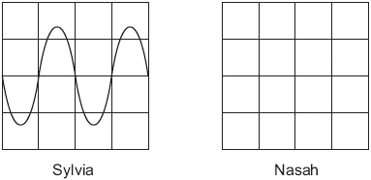

The sound Nasah heard was quieter but the pitch was the same.

On the right-hand grid, draw the trace to show the pattern of the sound Nasah heard.

2 marks

maximum 5 marks

**Level 7**

**5.** Sam turns his bicycle upside down and turns the pedals fast so that the back wheel spins.

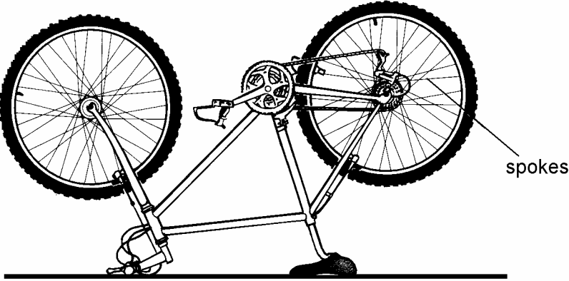

Sam holds a piece of card close to the back wheel.   
The spokes hit the piece of card and Sam hears a ‘musical’ tone.

(a) Explain why the card produces a ‘musical’ tone.

......................................................................................................................

......................................................................................................................

1 mark

(b) When the spokes hit the piece of card, the wheel slows down

(i) Describe the energy change which occurs as the wheel slows down.

............................................................................................................

............................................................................................................

1 mark

(ii) Describe and explain what will happen to the pitch of the ‘musical’ tone as the wheel slows down.

............................................................................................................

............................................................................................................

2 marks

Maximum 4 marks

# Light

***• Use light travelling in a straight line to explain the formation of***

***shadows and other phenomena.***

***• Describe how non-luminous objects are seen.***

***• Describe reflection at a plane surface and use the law of reflection.***

***• Investigate refraction at the boundary between air and glass or air***

***and water.***

***• Explain the dispersion of white light.***

***• Explain colour addition and subtraction, and the absorption and***

***reflection of coloured light.***

**1.** Nadia is on her bicycle, waiting to pull out from a road junction.   
Michael is driving his car round the bend. A row of houses stops Nadia from seeing Michael's car.

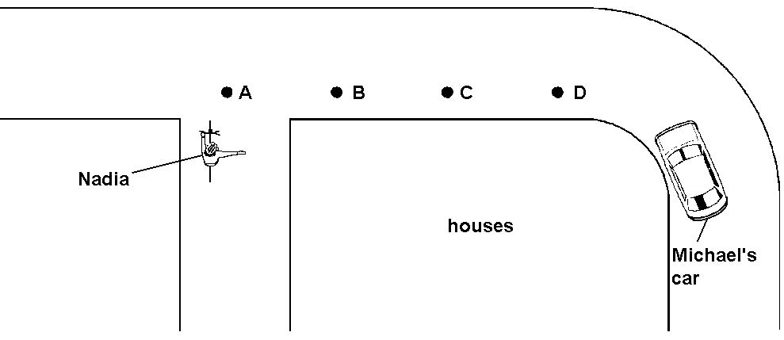

*not to scale*

(a) At what position will Michael's car be when Nadia first sees it?  
Tick the correct box.

A  B  C  D 

1 mark

(b) A row of shops was built opposite the junction. The shops have glass windows which act as a mirror.

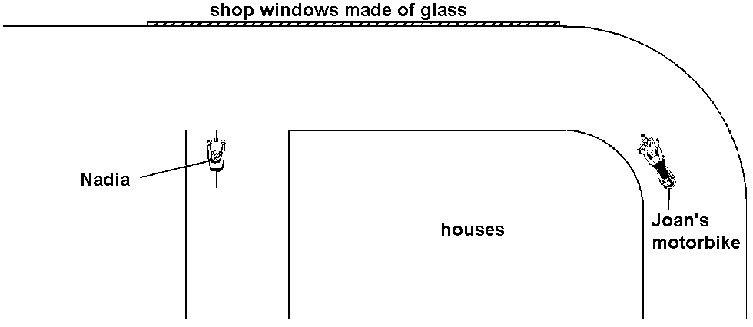

*not to scale*

Nadia could see Joan's motorbike reflected in the glass window.

(i) **On the diagram above**, draw a ray of light to show how Nadia can see Joan's motorbike reflected in the glass window.   
Add arrows to the ray. Use a ruler.

3 marks

(ii) How does the glass window help to reduce the number of accidents?

.............................................................................................................

.............................................................................................................

1 mark

Maximum 5 marks

**Level 6**

**2.** The diagram shows a ray of light hitting the surface of a mirror made from thick glass.  
The incident ray is both reflected and refracted.



(a) (i) Give the letters of the **two** reflected rays.

............... and ...............

1 mark

(ii) Give the letter of **one** refracted ray.

...............

1 mark

(b) The incident ray is brighter than ray A.  
Give **one** reason for this.

.....................................................................................................................

.....................................................................................................................

1 mark

maximum 3 marks

**Level 6**

**3.** The diagram below shows the shapes and positions of five glass objects.



Harriet put a square of black card on top of each glass object.   
She shone a ray of red light onto each object.



The diagrams below show the rays of light going under the cards and coming out again.  
Which object is under each card? Write the correct letter below each diagram.  
One has been done for you.

4 marks







Maximum 4 marks

**Level 7**

**4.** Sunita puts on a pair of special glasses as shown below. The glasses have coloured filters in them.

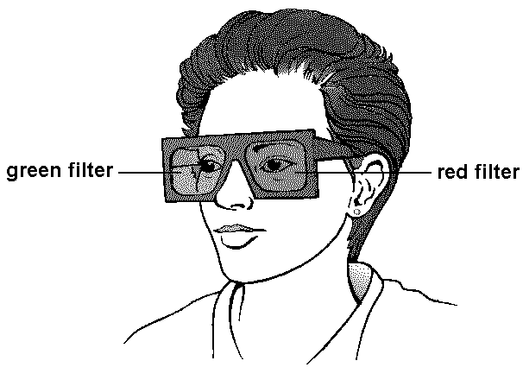

(a) Sunita looks at a lamp through the green filter. The lamp gives out white light, but appears to be green.  
Explain how this is possible.

.....................................................................................................................

.....................................................................................................................

.....................................................................................................................

2 marks

(b) Sunita looks at a red lamp.

(i) What colour will the lamp appear to Sunita, if she looks at it through the red filter?

.............................................................................................................

Explain your answer.

.............................................................................................................

.............................................................................................................

1 mark

(ii) What colour will the lamp appear to Sunita, if she looks at it through the green filter?

.............................................................................................................

Explain your answer.

.............................................................................................................

.............................................................................................................

2 marks

Maximum 5 marks

**Level 7**

**5.** (a) Peter tried to obtain a mixture of red and green light.  
He used white light from a spotlight and slotted a red filter and a green filter in front of it as shown below.

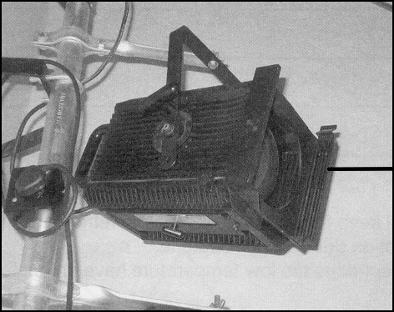

The diagram below represents Peter’s experiment.



(i) **No** light reached the screen. Explain why.

.............................................................................................................

.............................................................................................................

.............................................................................................................

2 marks

(ii) Peter cut a circular hole in the green filter. Describe what Peter would see on the screen.

.............................................................................................................

.............................................................................................................

1 mark

(b) Peter used two spotlights to shine a mixture of red and green light on to some red curtains.

(i) What colour did the red curtains appear in this light?

...................................................

1 mark

(ii) Give the reasons why they appeared this colour.

.............................................................................................................

.............................................................................................................

.............................................................................................................

.............................................................................................................

2 marks

Maximum 6 marks

# Magnetism

***• Describe the properties of magnets.***

***• Recognise and reproduce the magnetic field pattern of a bar magnet.***

***• Construct and use an electromagnet.***

**1.** (a) Debbie put a paper cup into a glass beaker.  
She glued a magnet in the bottom of the paper cup.  
She glued another magnet in the bottom of the beaker.  
The magnets repelled.



**diagram A**

*not to scale*

What **two** forces act on the paper cup and its contents to keep it in this position?

1. ...........................................................

1 mark

2. ...........................................................

1 mark

(b) Debbie put 5 g of aluminium rivets into the paper cup.  
It moved down a little as shown in diagram B.



**diagram B**

*not to scale*

Debbie plotted a graph to show how the mass of aluminium rivets affected the distance the cup moved down.



(i) Use the graph to find the mass that made the cup move down 4 mm.

............... g

1 mark

(ii) Why did the graph stay flat with masses greater than 40 g?

.............................................................................................................

1 mark

(c) Debbie removed the 5 g of aluminium rivets and put 5 g of iron nails into the cup.



**diagram C**

*not to scale*

The paper cup moved down more with 5 g of iron nails than with 5 g of aluminium rivets as shown in diagram C.  
Give the reason for this.

.....................................................................................................................

.....................................................................................................................

1 mark

maximum 5 marks

**Level 6**

**2.** Alex makes an electromagnet.  
She winds insulated wire around an iron nail.  
She connects the wire to a power supply.  
She uses the electromagnet to pick up some steel paper-clips.

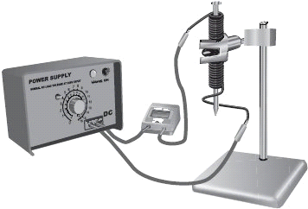

This is her prediction.

|  |
| --- |
| **The more turns of wire around the iron nail the stronger the electromagnet becomes.** |

(a) (i) Give the **one** factor she should change as she investigates her prediction.

.............................................................................................................

.............................................................................................................

1 mark

(ii) Give **one** factor she should keep the same.

.............................................................................................................

.............................................................................................................

1 mark

(iii) Describe how she could use the paper-clips to measure the  
strength of the electromagnet.

.............................................................................................................

.............................................................................................................

1 mark

(b) Alex wrote a report of her investigation.

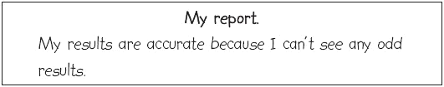

What would an odd result suggest?

......................................................................................................................

......................................................................................................................

1 mark

(c) (i) Which size paper-clips would Alex use to make her results more  
accurate?  
Tick the correct box.

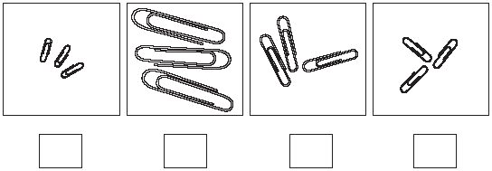

1 mark

(ii) Give a reason for your choice.

.............................................................................................................

.............................................................................................................

.............................................................................................................

1 mark

maximum 6 marks

**Level 7**

**3.** A reed switch is made of two iron strips inside a glass tube.  
The iron strips close together when a magnet is brought near.  
They spring apart again when the magnet is removed.

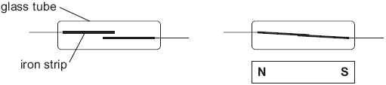

(a) Hilary set up the circuit shown below.  
She tried to close the reed switch using an electromagnet.

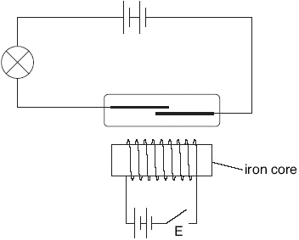

She closed switch E but the electromagnet was **not** strong enough to close the reed switch.

(i) Give **two** ways Hilary could increase the strength of the electromagnet.

1. .........................................................................................................

2. .........................................................................................................

2 marks

(ii) Hilary increased the strength of the electromagnet.  
The reed switch closed.  
The iron strips were magnetised as shown below.



She reversed the current in the coil of the electromagnet.  
**On the diagram below**, label the poles of the iron strips when the  
current was reversed.



1 mark

(b) (i) Iron and steel are both magnetic materials.  
Explain why the strips must be made of iron and **not** steel.

.............................................................................................................

.............................................................................................................

1 mark

(ii) She replaced the reed switch with a piece of copper wire.  
The current through the bulb increased.

Explain why more current flowed through the bulb when the reed switch was replaced with copper wire.

.............................................................................................................

.............................................................................................................

1 mark

maximum 5 marks

Level 7

**4.** (a) A pupil makes a small coil of copper wire and passes an electric current through it.   
The pupil places a small magnet near the coil.



The magnet is attracted towards the coil. The pupil turns the magnet around so that the South pole is nearest the coil.  
What effect, if any, will this have?

……….………………………………………………………………………………

……….………………………………………………………………………………

1 mark

(b) The pupil uses the coil and the magnet to make a simple ammeter to measure the current through a bulb.



*not to scale*

(i) The paper clip is used to balance the weight of the magnet.  
Why is the paper clip further away from the pivot than the magnet is?

…………………………………………………………………………………

…………………………………………………………………………………

1 mark

(ii) Explain how a current in the coil makes the straw pointer move.

…………………………………………………………………………………

…………………………………………………………………………………

…………………………………………………………………………………

2 marks

(iii) The pupil places a piece of soft iron in the middle of the coil.  
Describe and explain how this will affect the reading on the scale when the same current flows through the coil.

…………………………………………………………………………………

…………………………………………………………………………………

…………………………………………………………………………………

…………………………………………………………………………………

2 marks

Maximum 6 marks

Level 7

**5.** A pupil wound a coil of copper wire around a glass tube and connected the wire to a battery. She placed a compass at each end of the tube and one compass beside the tube as shown.



(a) (i) Complete the diagram by drawing arrows in compasses X and Y to show the direction of the magnetic field.

2 marks

(ii) Draw an arrow in the middle of the glass tube to show the direction of the magnetic field in the glass tube.

1 mark

(iii) When the switch is opened, in which direction will the three compass needles point?

...................................................................

1 mark

(b) Give **one** way to reverse the magnetic field around the glass tube

......................................................................................................................

......................................................................................................................

1 mark

(c) Two pieces of iron are placed inside the glass tube.

(i) When the switch is closed, the magnetic field is the same as in the  
diagram opposite. The pieces of iron become magnetised.  
Label the **four** poles on the pieces of iron.



1 mark’

(ii) When the switch was closed, the pieces of iron moved.  
Explain why they moved.

............................................................................................................

............................................................................................................

1 mark

Maximum 7 marks

# Electricity

***• Describe electrostatics and the concept of charge, including digital***

***sensors.***

***• Interpret and draw simple parallel circuits.***

***• Model and explain how common types of components, including***

***cells (batteries), affect current.***

***• Explain how current divides in parallel circuits.***

***• Measure current using ammeters and voltage using voltmeters,***

***including digital meters.***

**1.** The diagram shows two dodgem cars at a fairground. The circuit symbols for the motor and pedal for each dodgem car are shown on the diagram.



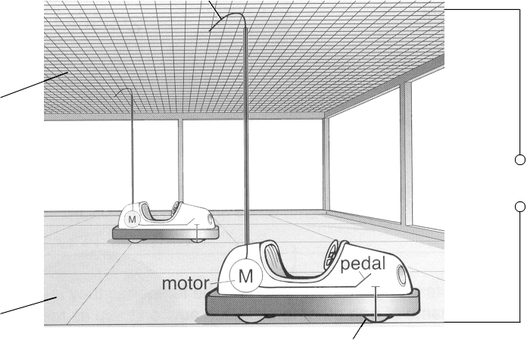



(a) Complete the following sentence.

Each dodgem car is connected to the power supply through the

......................................... which is in contact with the wire

mesh, and through the ......................................... which is

in contact with the metal floor.

1 mark

(b) Dodgem cars are connected using parallel circuits.  
Complete the circuit diagram below for the **two** dodgem cars.  
Use **two** motor symbols, , and **two** switch symbols, .  
The power supply for the circuit has been drawn for you.



2 marks

(c) Even when the power supply is switched on, the dodgem car will **not** move until the pedal is pressed. Give the reason for this.

.....................................................................................................................

.....................................................................................................................

1 mark

(d) A man looks after the dodgem cars during the rides.  
Why does the man **not** get an electric shock as he walks across the metal floor?

.....................................................................................................................

.....................................................................................................................

1 mark

(e) During one ride, the two dodgem cars are running. The pick-up wire on one car snaps off. Describe how this affects:

(i) the dodgem car with the broken pick-up wire;

.............................................................................................................

1 mark

(ii) the other dodgem car.

.............................................................................................................

1 mark

Maximum 7 marks

**Level 5**

**2.** The back window of this car contains a heating element.

The heating element is part of an electrical circuit connected to the battery of the car.

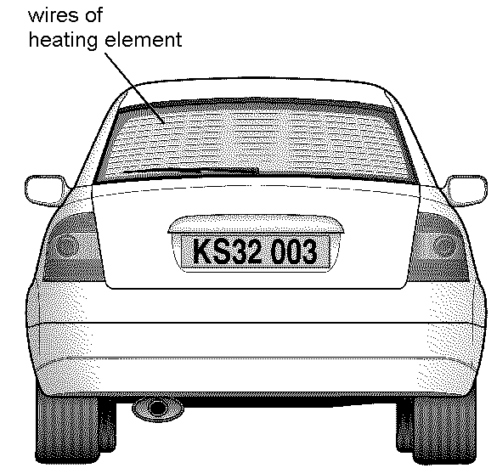

The diagrams below show **two** ways of connecting the circuit of a heating element.



(a) Give the name of each type of circuit:

circuit A ...................................................................

circuit B ...................................................................

1 mark

(b) A wire gets broken at point X on circuit A and at point Y on circuit B.



When the switch is closed, how does the broken wire affect the heating   
element in:

(i) circuit A? ............................................................................................

...........................................................................................................

1 mark

(ii) circuit B? .............................................................................................

.............................................................................................................

1 mark

(c) In very cold weather, ice may form on the back window of the car.   
When the heating element is switched on, the ice will disappear and the surface of the window will become clear and dry.

(i) Fill the gap below to show the energy transfer that takes place.

When the heater is switched on, ........................................ energy is transferred from the wires to the ice.

1 mark

(ii) As the window becomes clear and dry, physical changes take place in the ice.  
Fill the gaps below to show the physical changes which take place.

from …………………. to ……………………….to ……………………

1 mark

Maximum 5 marks

**Level 6**

**3.** Imran built a puzzle circuit with three identical bulbs and a 3V battery.  
He covered the connections to the bulbs with a piece of card as shown below.  
The bulbs could be seen through holes in the card.



All the bulbs were on but their brightness was different.

Lucy removed bulbs A, B and C in turn. Before connecting each bulb back into the circuit she observed the effect on the other two bulbs.  
She recorded her observations in the table below.

|  |  |
| --- | --- |
| **bulb removed** | **observations** |
| A | B and C stayed on |
| B | C went off A stayed on |
| C | B went off A stayed on |

(a) Complete the circuit diagram below to show how the three bulbs could be connected.  
Use your knowledge of series and parallel circuits, and the observations in the table to help you.



2 marks

(b) Imran used three identical bulbs but their brightness was different.

Which bulb was the brightest? Give the letter.

...............

Give the reason for your choice.

.....................................................................................................................

.....................................................................................................................

1 mark

(c) Imran added a switch to the circuit so that he could turn all three bulbs  
on and off at the same time.

Place a letter **S** on your circuit diagram where this switch could be placed.

1 mark

maximum 4 marks

**level 6**

**4.** Peter measured the current through each of three similar bulbs in a parallel circuit.



He had only one ammeter and he placed it first at A1, then A2, then A3, in order to measure the currents.

The table shows his results.

|  |  |
| --- | --- |
| **position of ammeter** | **current, in amps** |
| A1 | 0.14 |
| A2 | 0.16 |
| A3 | 0.15 |

(a) He expected the current readings to be the **same** for each bulb but found they were **different**.

Suggest **two** reasons why the readings were different.

1. ................................................................................................................

2. ................................................................................................................

2 marks

(b) Peter then measured the current at **A4** and recorded it as 0.45 A. He concluded that the current at **A4** could be calculated by adding together the currents through each of the bulbs at positions **A1**, **A2** and **A3.**



He added two more similar bulbs to his circuit, in parallel. The current through each bulb was 0.15 A.  
Use Peter's conclusion to predict the current at **A4** with the 5 bulbs in the circuit.

................ A



1 mark

(c) Peter left the circuit connected overnight. He used a datalogger to measure the current at position **A4** at regular intervals of time. The next morning the bulbs were dim.

Using the axes below, sketch (do **not** plot) how the current at position **A4** might change with time.

Indicate on the graph:

(i) The correct labels for each axis, including the correct units.

(ii) The shape of the graph you would expect to obtain.



2 marks

Maximum 5 marks

**Level 6**

**5.** Lorna built the circuit drawn below. All the bulbs are identical.

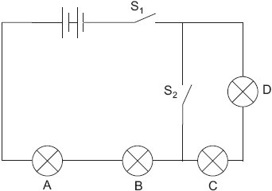

(a) Complete the table below by writing **on** or **off** for each bulb.

|  |  |  |  |  |  |
| --- | --- | --- | --- | --- | --- |
| **switch** | | **bulb** | | | |
| **S1** | **S2** |  |  | **A** | **B** |
| open | open |  |  | off | off |
| open | closed |  |  |  |  |
| closed | open |  |  |  |  |
| closed | closed |  |  |  |  |

3 marks

(b) Lorna then built a different circuit as shown below.

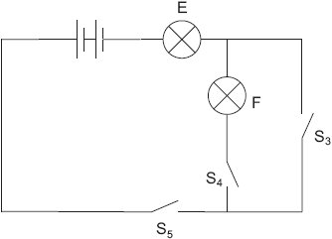

How could Lorna get both bulbs to light at the same time in this circuit?

......................................................................................................................

......................................................................................................................

1 mark

maximum 4 marks

# Forces and motion II

***• Explain that pressure is caused by the action of a force on an area.***

***• Determine densities of solids, liquids and gases.***

***• Explain pressures in gases and liquids (qualitative only).***

***• Know that forces can cause objects to turn on a pivot and understand***

***the principle of moments.***

**1.** The drawing below shows a cardboard scale called an EasyWeigh.  
It can be used to estimate the mass of letters.



(a) Clare put a letter in the 20 g slot. The scale tipped as shown below.



She then put the same letter in the 40 g slot. The scale did **not** tip.

(i) What do these results tell you about the mass of Clare’s letter?

...............................................................................................................

...............................................................................................................

1 mark

(ii) What could Clare do to this cardboard scale to weigh her letter more accurately?

...............................................................................................................

...............................................................................................................

1 mark

(b) (i) Clare drew a short line to show where she thought she should cut a slot to weigh a 150 g letter. She labelled the slot Y.



Why could Clare **not** use a slot at Y to weigh a 150 g letter?

...............................................................................................................

...............................................................................................................

1 mark

(ii) Clare wanted to cut a slot to weigh a 70 g letter.

On the diagram above, draw a short line to show where the slot should be cut.

1 mark

maximum 4 marks

Level 7

**2.** (a) The diagram below shows a car park barrier.



(i) Calculate the turning moment produced by the barrier about the pivot.  
Give the unit.

.............................................................................................................

.............................................................................................................

.............................................................................................................

2 marks

(ii) The barrier is horizontal. The weight of the barrier is balanced by an iron counterweight. Calculate the downward force produced by the counterweight.

.............................................................................................................

.......................................................................................................... N

1 mark

(b) An electromagnet is placed beneath the iron counterweight as shown below.



When the switch is closed the barrier rises.  
Explain how the electromagnet can be used to raise the barrier.

.....................................................................................................................

.....................................................................................................................

.....................................................................................................................

.....................................................................................................................

.....................................................................................................................

2 marks

maximum 5 marks

**Level 7**

**3.** The diagram below shows a container filled with a liquid.



At each end of the container there is a piston.  
Piston A has a smaller area than piston B.

(a) (i) Rebekah pushes on the pedal. This produces a force of 200 N on piston A.

Calculate the pressure that piston A exerts on the liquid.  
Give the unit.

...............................................................................................................

...............................................................................................................

2 marks

(ii) The liquid in the container exerts the same pressure on piston B.

Use this pressure to calculate the force on piston B.

...............................................................................................................

............................................................................................................. N

1 mark

(b) Rebekah set up a different experiment as shown below.  
She measured the volume of the liquid and the air in the  
cylinders before and after a 200 g load was added to the piston.



(i) When the loads were added to the pistons, the volume of the liquid did **not** change but the volume of the air decreased.

Explain why this happened.

...............................................................................................................

...............................................................................................................

1 mark

(ii) The diagram on the opposite page represents the way the brake system of a car works.  
The brake pedal pushes piston A.  
Piston B pushes the brakes on.

If air bubbles get into the liquid, the brakes do **not** work properly.  
Explain why.  
Use the diagrams above to help you.

...............................................................................................................

...............................................................................................................

1 mark

maximum 5 marks

**Level 7**

**4.** A father makes a simple mobile for his young son. He uses plastic animals as shown below.

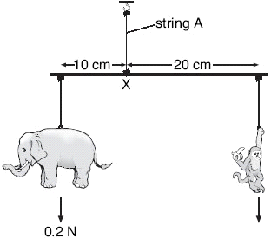

(a) (i) The elephant weighs 0.2 N.

What is the turning moment produced by the elephant about point X?  
Give the unit.

.............................................................................................................

.............................................................................................................

2 marks

(ii) What is the turning moment produced by the monkey about point X?

.............................................................................................................

.............................................................................................................

1 mark

(iii) What is the weight of the monkey?

............. N

1 mark

(b) What is the size of the tension (force) in string A?

............. N

1 mark

maximum 5 marks

**Level 7**

**5.** A pen cap floats in a plastic lemonade bottle three-quarters full of water.  
If you squeeze the bottle the pen cap sinks to the bottom.  
If you then let go of the bottle, the pen cap floats to the surface.



(a) When the bottle is squeezed what, if anything, happens to:

(i) the distance between the air molecules inside the bottle?

............................................................................................................

1 mark

(ii) the distance between the water molecules inside the bottle?

............................................................................................................

1 mark

(iii) the pressure of the air trapped inside the pen cap?

............................................................................................................

1 mark

(iv) the volume of the air trapped inside the pen cap?

............................................................................................................

1 mark

(b) Explain why the pen cap sinks when you squeeze the bottle.

......................................................................................................................

......................................................................................................................

......................................................................................................................

2 marks

Maximum 6 marks