IGCSE Electricity I – Homework 3 Name……………………………….
Aims

Core
• State that the e.m.f. of an electrical source of energy is measured in volts
• State that the potential difference (p.d.) across a circuit component is measured in volts
• Use and describe the use of a voltmeter, both analogue and digital
• State that resistance = p.d. / current and understand qualitatively how changes in p.d. or resistance affect current
• Recall and use the equation R = V / I
• Describe an experiment to determine resistance using a voltmeter and an ammeter
• Relate (without calculation) the resistance of a wire to its length and to its diameter

Supplement
• Show understanding that e.m.f. is defined in terms of energy supplied by a source in driving charge round a complete circuit
• Recall that 1 V is equivalent to 1 J / C
• Sketch and explain the current-voltage characteristic of an ohmic resistor and a filament lamp
• Recall and use quantitatively the proportionality between resistance and length, and the inverse proportionality between resistance and cross-sectional area of a wire

EMF and Potential Difference
There are two types of voltage ______________. and ______________ ______________ (p.d.).
A cell or power supply increases the amount of ______________ in a circuit.
The energy given to each unit of ______________ as it passes around the circuit, is called the e.m.f.
This can be thought of as the electrical pressure pushing the current around a circuit.
When the electrical current flows through a component it ______________ energy.
For example in a bulb ______________ energy is given out. The difference in the energy of each unit of ______________ is known as the potential difference.

Homework
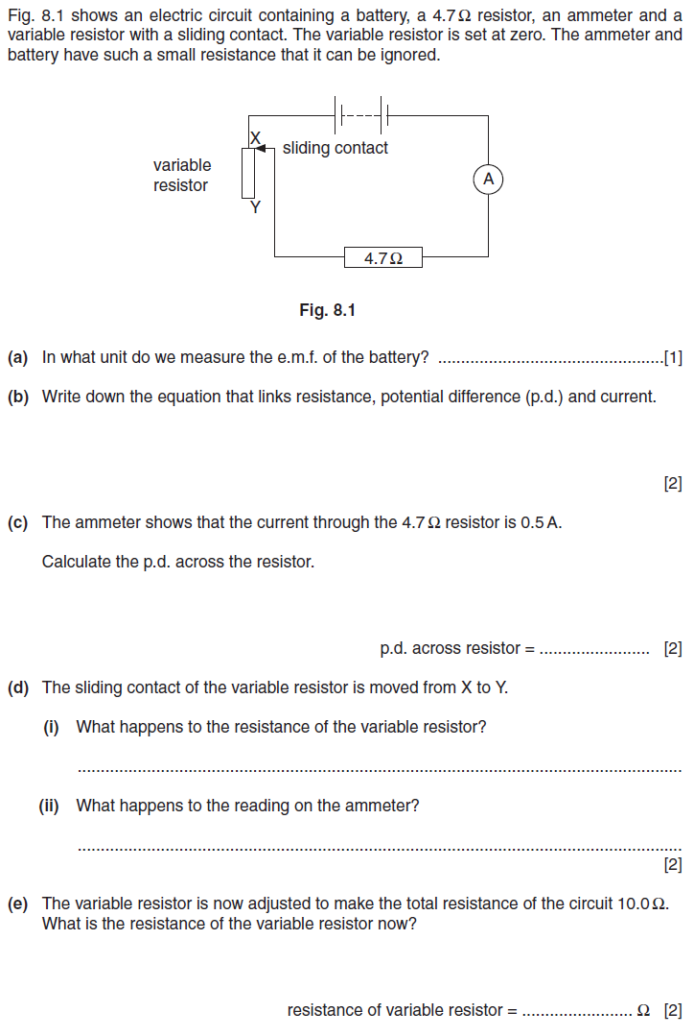028
2.
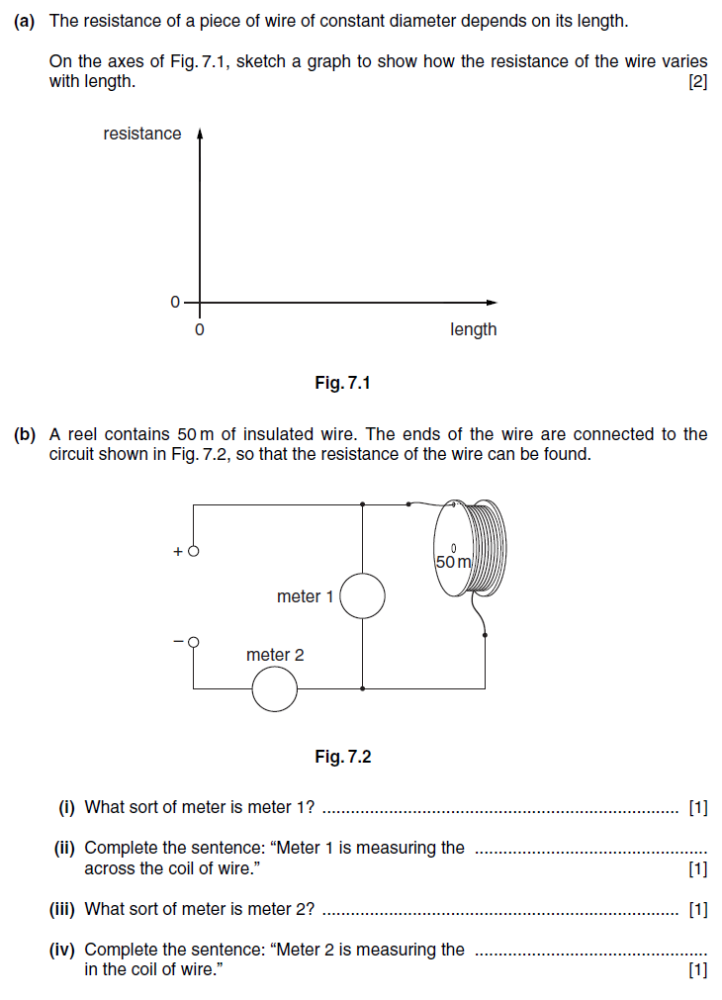
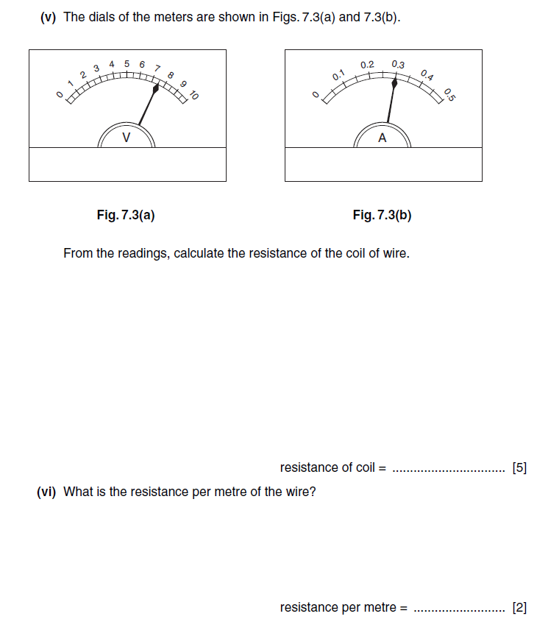037

Extended
3.
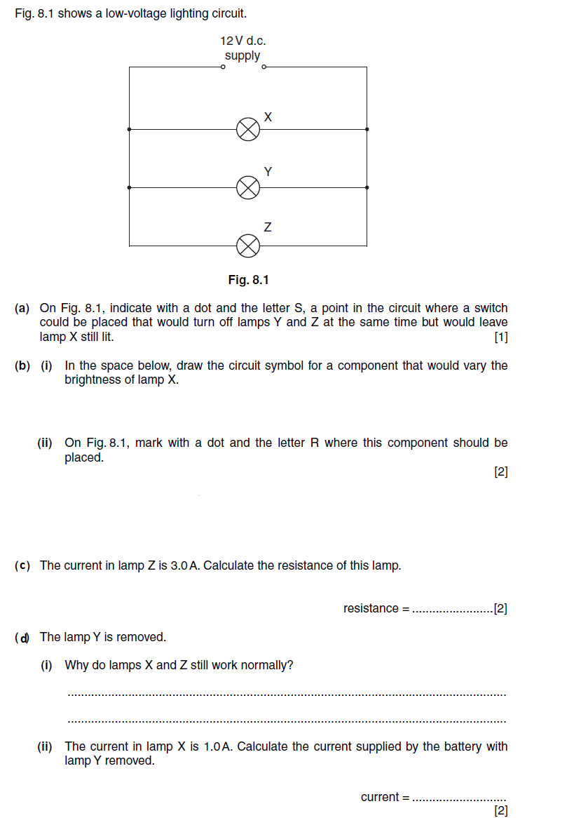068
Practical
4.
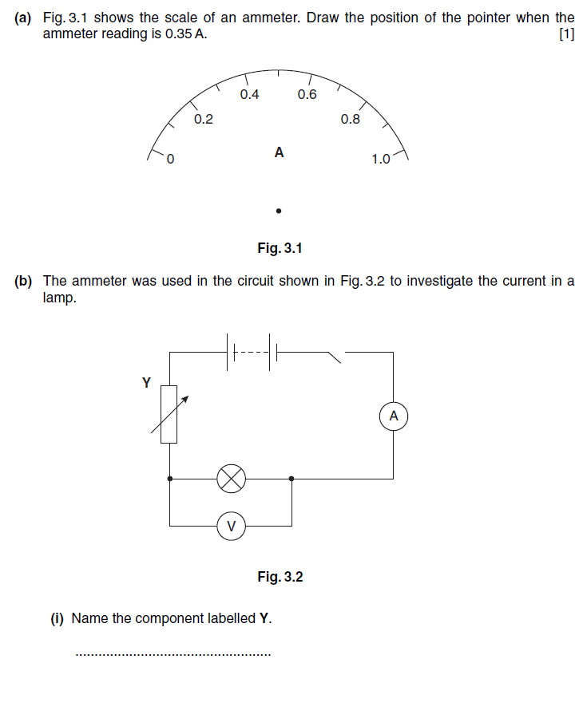
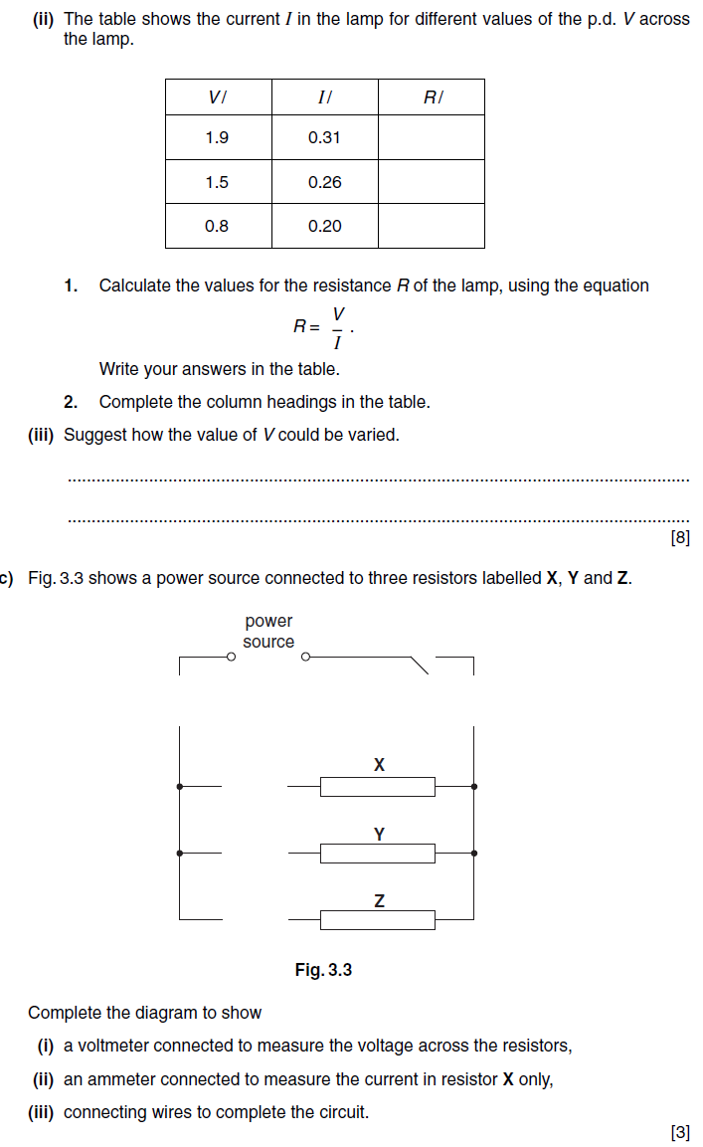033

