IGCSE MECHANICS II
HOMEWORK 1 – EFFECTS OF FORCES
TIME 25min
NAME…………………………………………………………………….. Total /22
CORE
- State that a force may produce a change in size and shape of a body.
- Plot extension/load graphs and describe the associated experimental procedure.
- Describe the ways in which a force may change the motion of a body.
EXTENDED
- Interpret extension/load graphs
- State Hooke’s Law and recall and use the expression F = k x
- Recognise the significance of the term ‘limit of proportionality’ for an extension/load graph

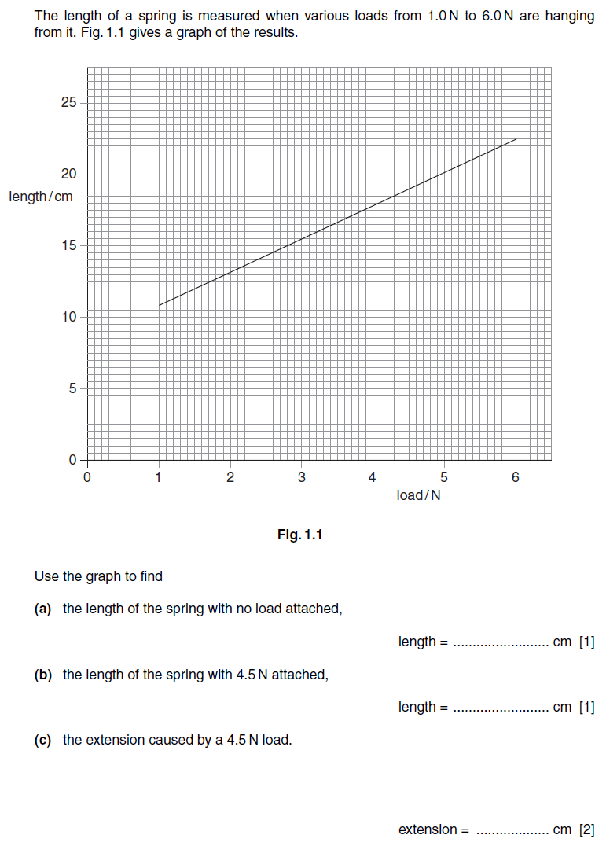
1.

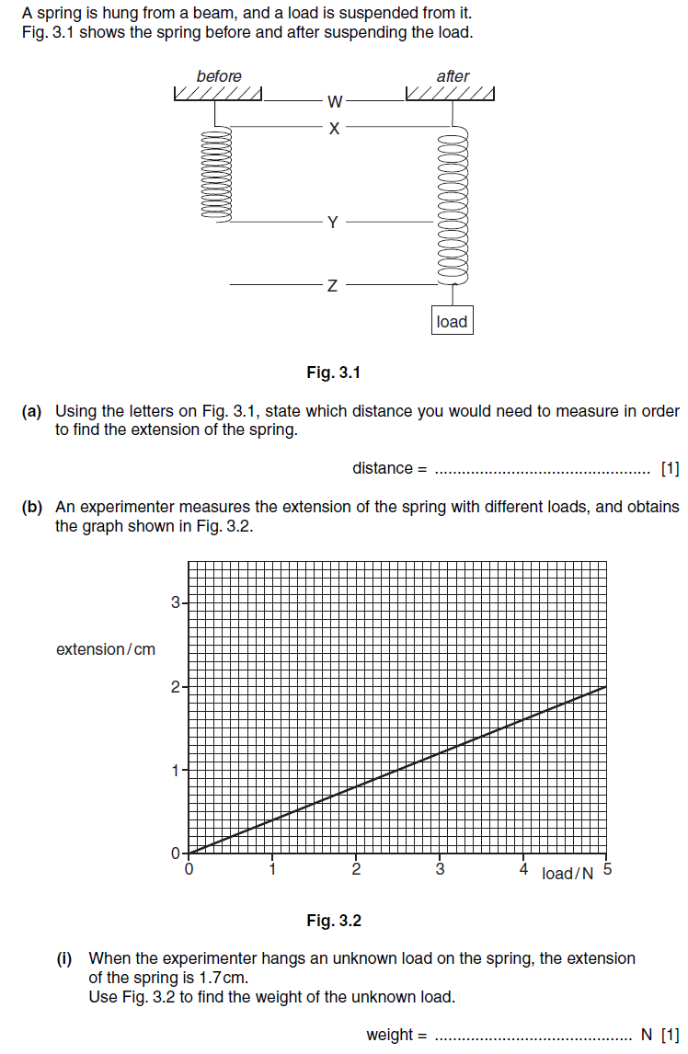
2.

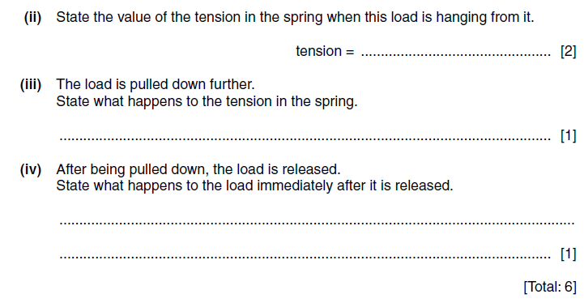

EXTENDED
3.
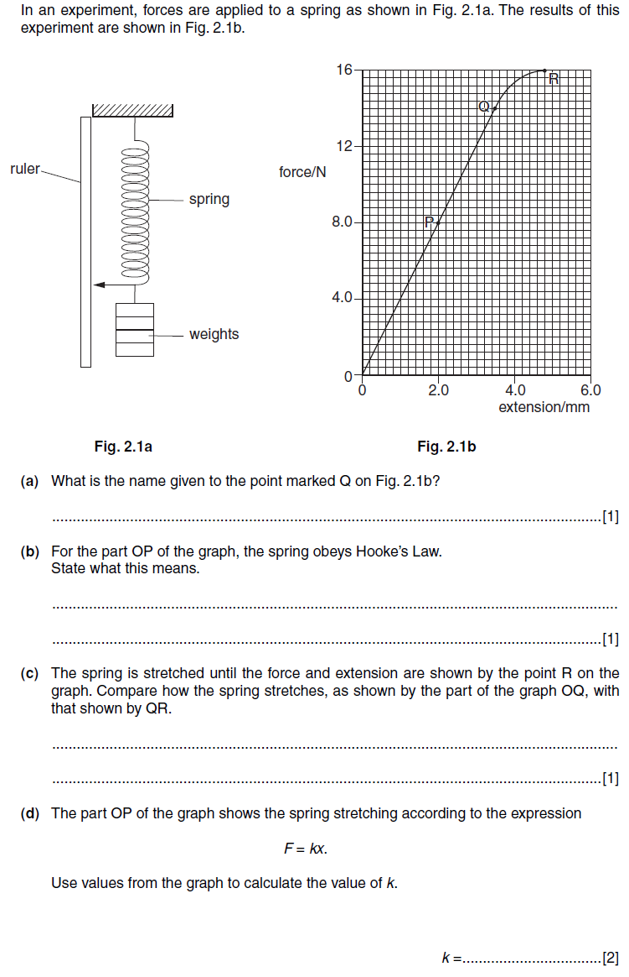

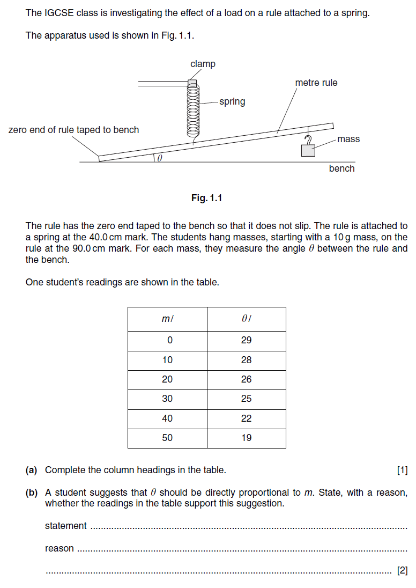
PRACTICAL
4.

