IGCSE MECHANICS II
HOMEWORK 2 – Turning effect
TIME 40min
NAME…………………………………………………………………….. Total /31
You should be able to:
Core
• Describe the moment of a force as a measure of its turning effect and give everyday examples
• Describe qualitatively the balancing of a beam about a pivot
• State that, when there is no resultant force and no resultant turning effect, a system is in equilibrium

Extended
• Perform and describe an experiment (involving vertical forces) to show that there is no net moment on a body in equilibrium
• Apply the idea of opposing moments to simple systems in equilibrium

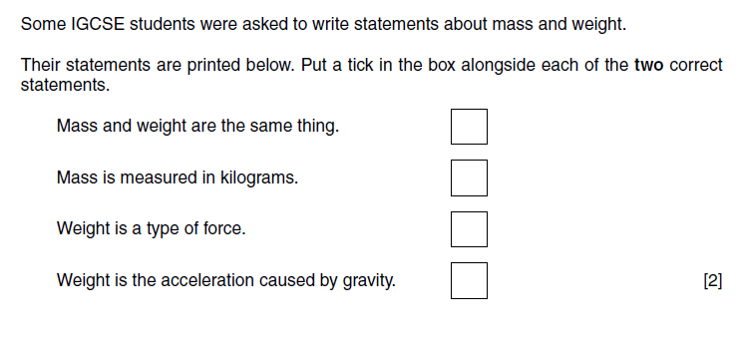
1

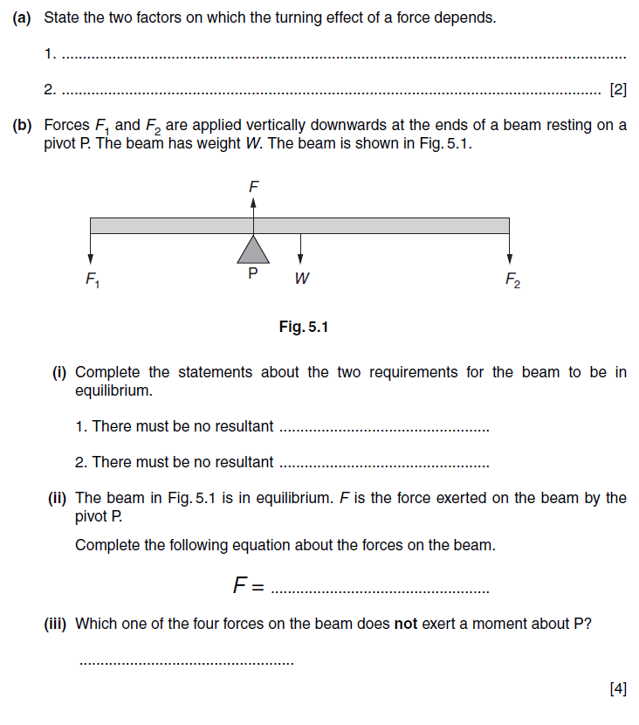
2

N06 2 5
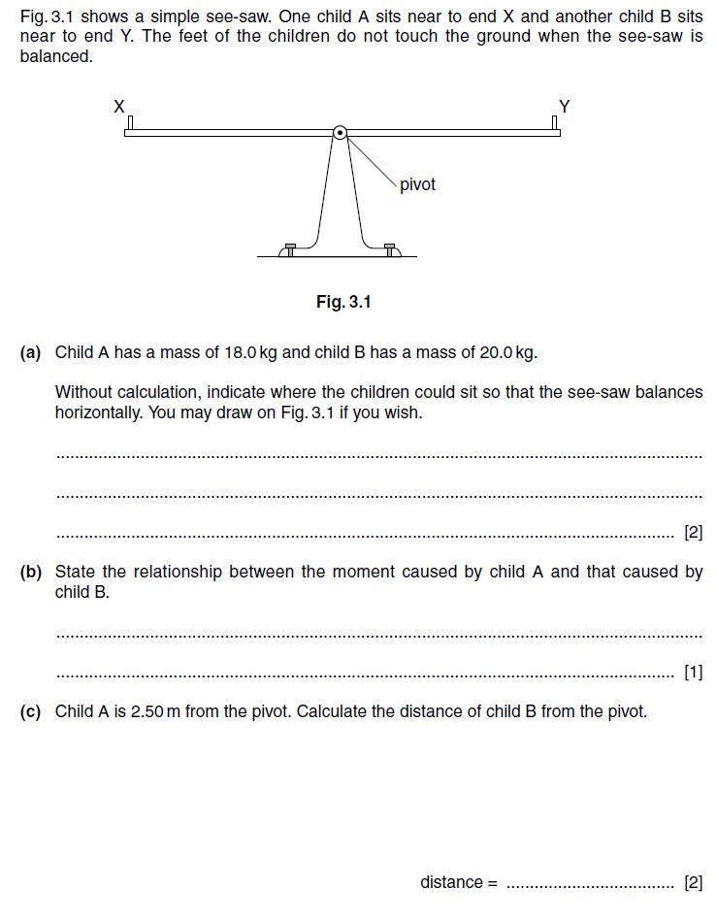
Extended questions
3

N03
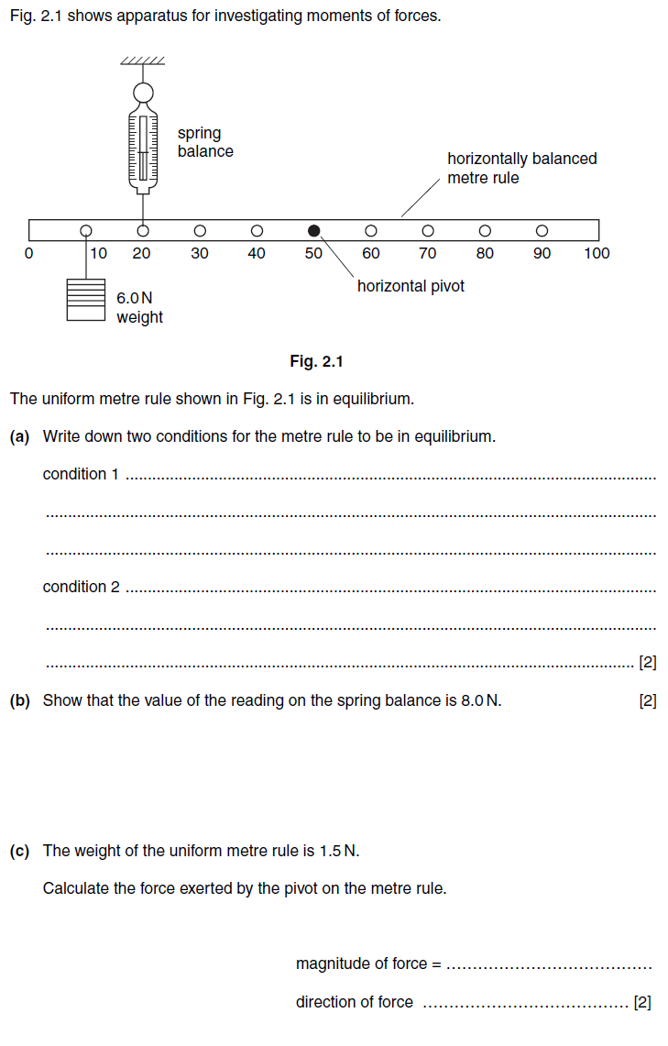
4

N05
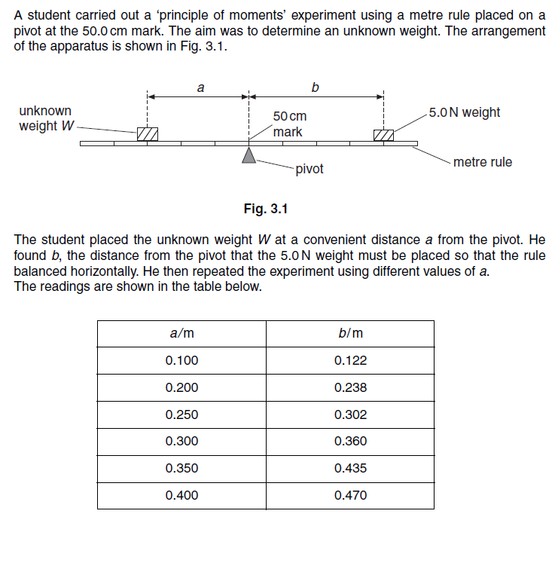
Practical
5

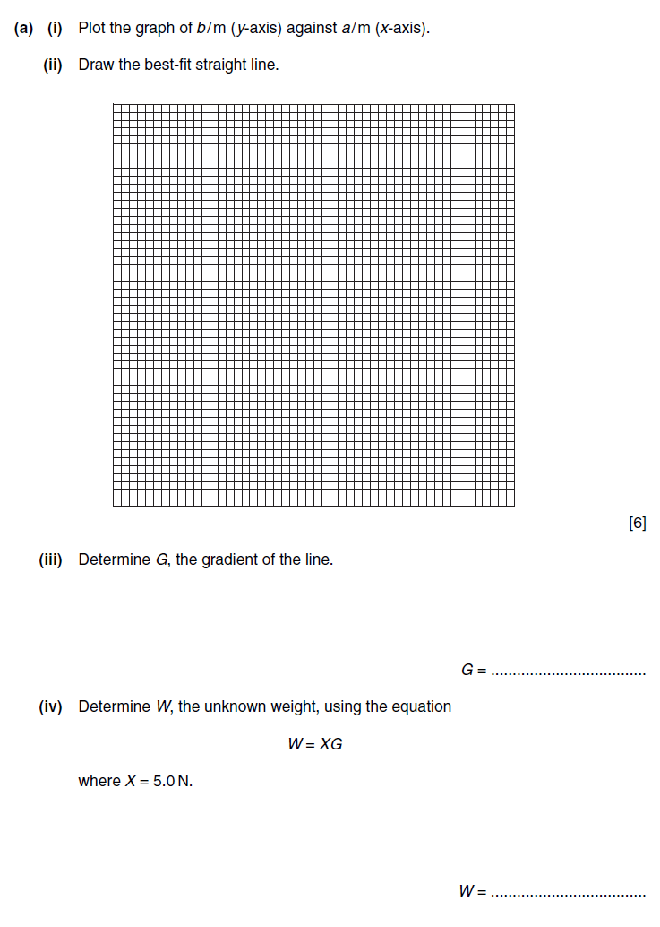
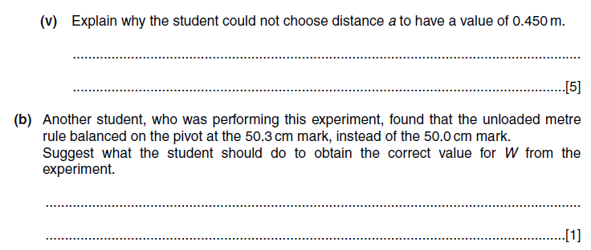

N02

