IGCSE MECHANICS II
HOMEWORK 3 – Centre of mass
TIME min
NAME…………………………………………………………………….. Total /
You should be able to:
Centre of mass
Core
• Perform and describe an experiment to determine the position of the centre of mass of a plane lamina
• Describe qualitatively the effect of the position ofthe centre of mass on the stability of simple objects

Scalars and vectors
Supplement
• Demonstrate an understanding of the difference between scalars and vectors and give common examples
• Add vectors by graphical representation to determine a resultant
• Determine graphically the resultant of two vectors

1.
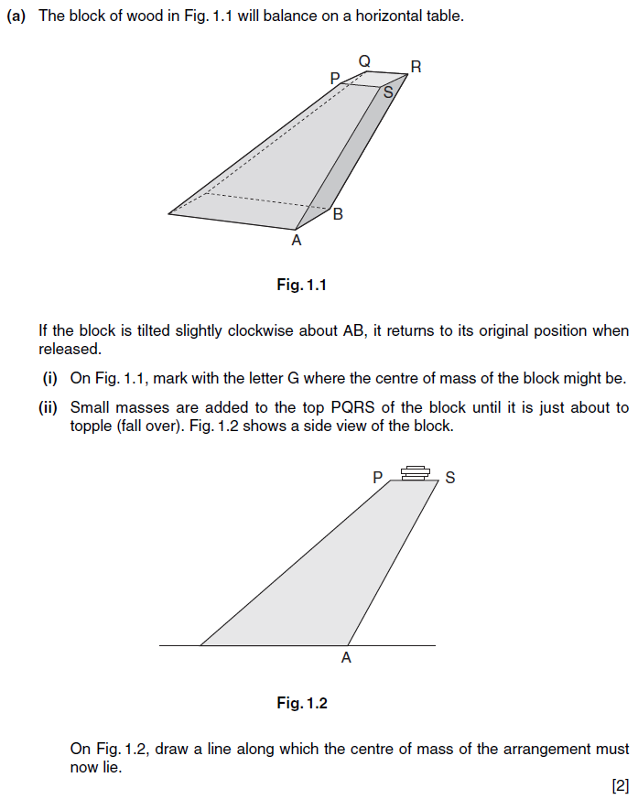

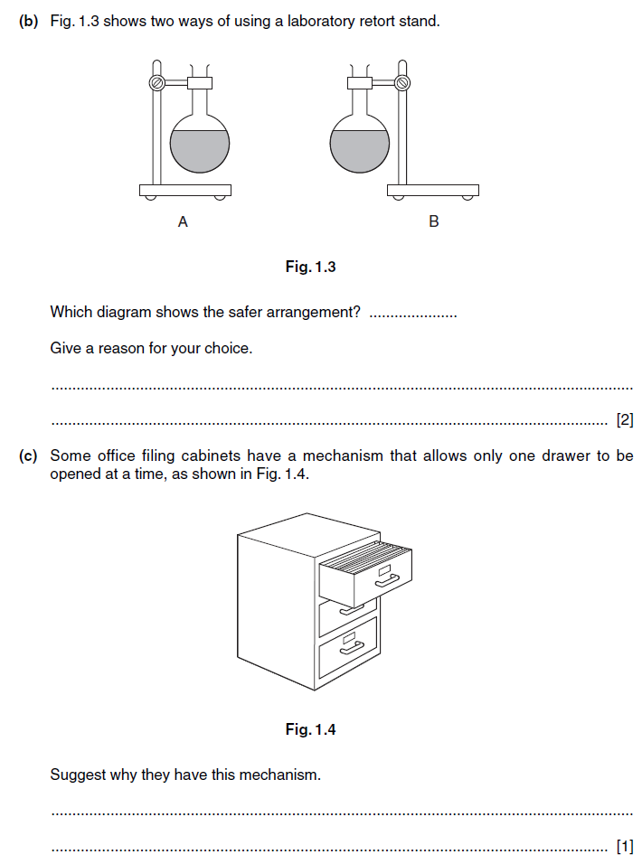
2.
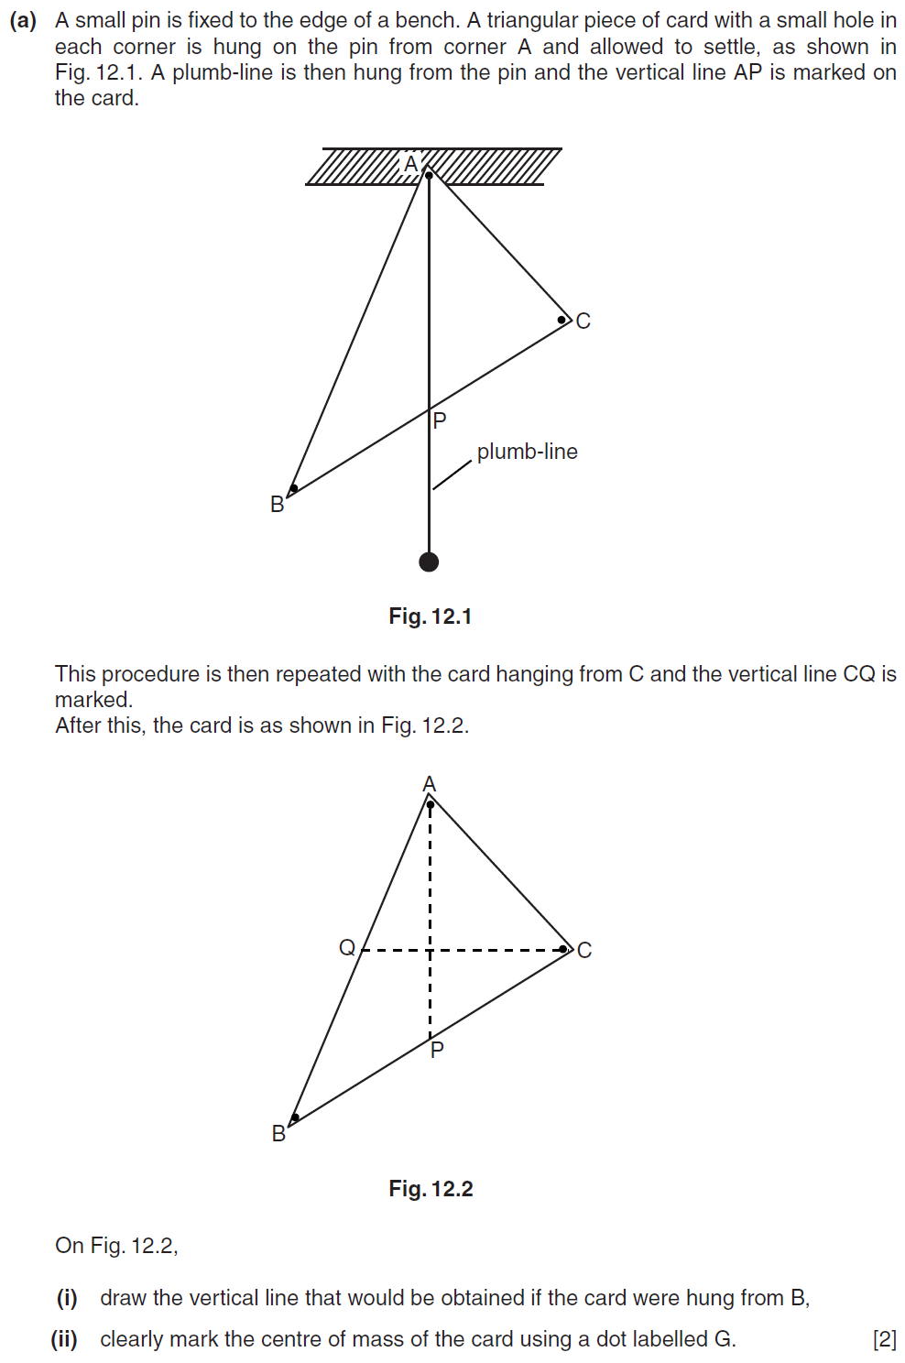
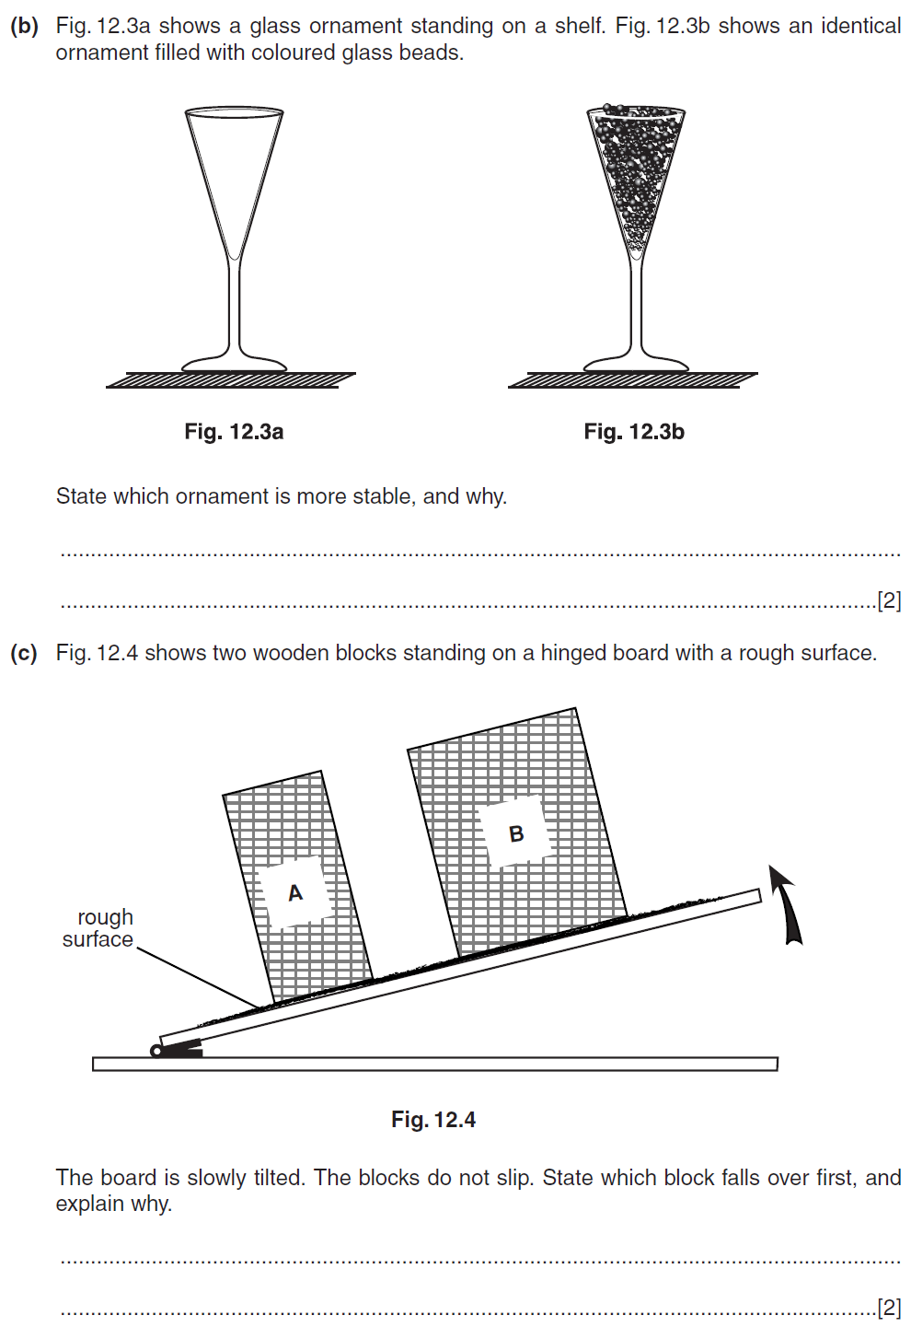
3. a) Define a scalar quantity and a vector quantity
Scalar - ………………………………………………………………………………………………………………………………………
........................................................................................................................................................
Vector - ………………………………………………………………………………………………………………………………………
.........................................................................................................................................................
b) Give 3 examples each of vector quantities and scalar quatities

Vector Quantity | Scalar Quantity

[5]

4.
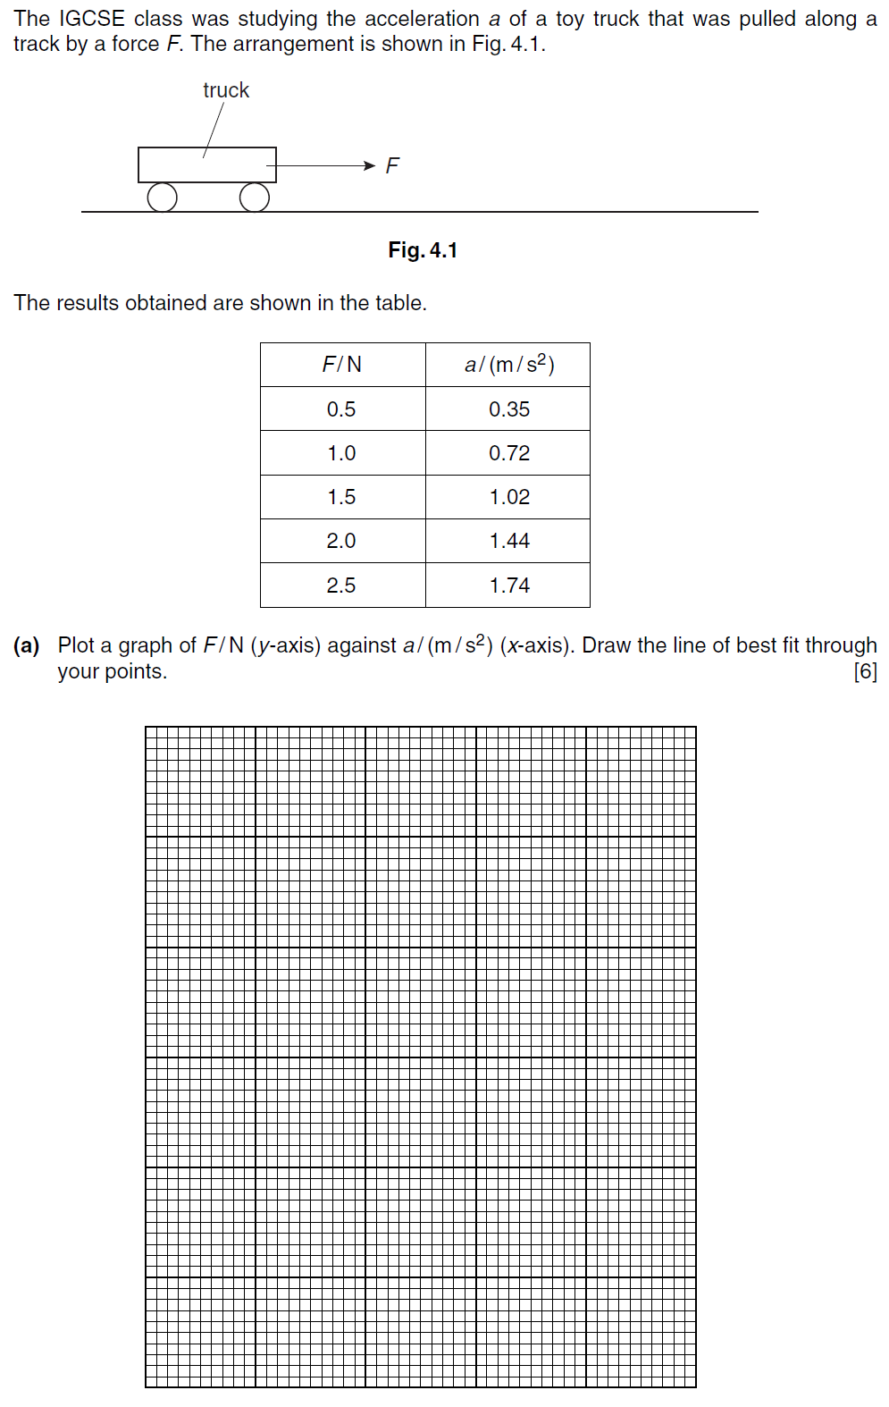
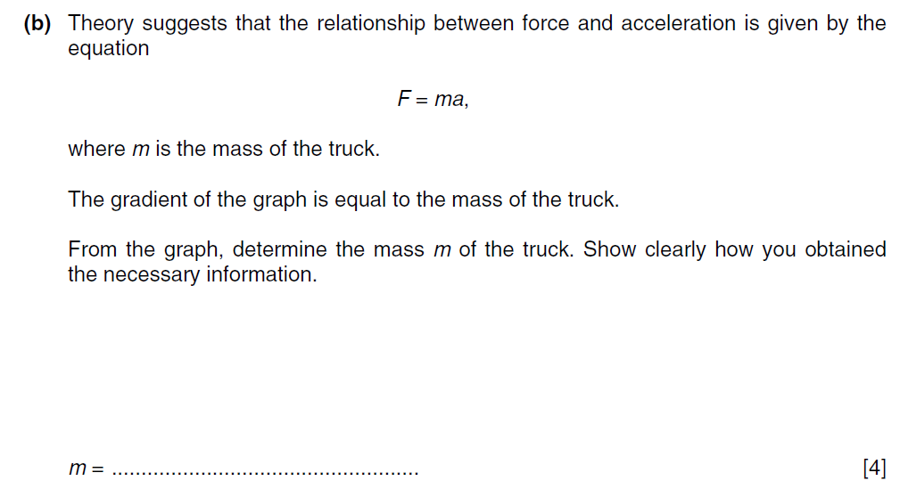

5.
