**Forces exam question booklet levels 5-7 (2006-2007)**

**Level 5**

**1.** The diagram shows four forces acting on a plane in flight.

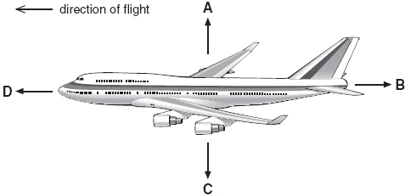

(a) Which arrow represents air resistance?  
Give the letter.

.............

1 mark

(b) (i) When the plane is flying at a constant height, which **two** forces must be balanced?  
Give the letters.

............. and .............

1 mark

(ii) When the plane is flying at a constant speed in the direction shown, which **two** forces must be balanced?  
Give the letters.

............. and .............

1 mark

(c) (i) Just before take-off, the plane is speeding up along the ground.

Which statement is true?  
Tick the correct box.

|  |  |
| --- | --- |
| Force B is zero. |  |
| Force B is greater than force D. |  |
| Force D is equal to force B. |  |
| Force D is greater than force B. |  |

1 mark

(ii) Which statement is true about the plane just as it leaves the ground?  
Tick the correct box.

|  |  |
| --- | --- |
| Force C is zero. |  |
| Force C is greater than force A. |  |
| Force A is equal to force C. |  |
| Force A is greater than force C. |  |

1 mark

maximum 5 marks

**Level 6**

**2.** Anil sits on a mat at the top of a helter-skelter and then slides down a chute around the outside.



(a) (i) Name **two** of the forces acting on Anil as he slides from point A to point B.

1. ....................................................................

2. ....................................................................

2 marks

(ii) As Anil slides from point A to point B, the forces acting on him are balanced.

Describe Anil's speed when the forces acting on him are balanced.

.............................................................................................................

1 mark

(b) Anil goes back for a second go. This time he sits on a smooth cushion instead of a mat.

He goes much faster on the cushion. Give the reason for this.

.....................................................................................................................

1 mark

(c) On his third go Anil lies back on the cushion with his arms by his side.

What happens to his speed? Give the reason for your answer.

.....................................................................................................................

.....................................................................................................................

.....................................................................................................................

2 marks

Maximum 6 marks

**Level 6**

**3.** The drawing below shows an astronaut in space.  
He has four small jets attached to his space suit.  
These jets produce forces on the **astronaut** in the directions A, B, C and D.

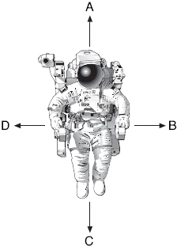

(a) The drawing below shows the size and direction of four forces acting  
on the astronaut.

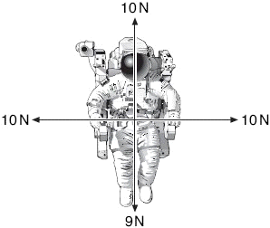

In which direction, A, B, C or D, will the astronaut move?

Give the letter.

..............

1 mark

(b) The drawing below shows the size and direction of four different  
forces acting on the astronaut.

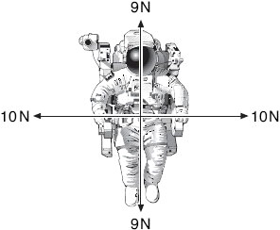

What will happen to the astronaut when the jets produce these four forces?

......................................................................................................................

1 mark

Explain your answer.

......................................................................................................................

......................................................................................................................

1 mark

(c) The drawing below shows the size and direction of four different  
forces acting on the astronaut.

Draw an arrow on the diagram below to show the direction in which he  
will move.

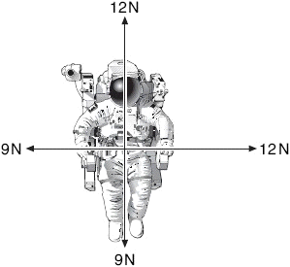

1 mark

maximum 4 marks

**level 6**

**4.** Russell investigated the relationship between mass and weight.  
He weighed five different masses using a force meter.

His results are shown in the table.

|  |  |
| --- | --- |
| **mass (g)** | **weight (N)** |
| 150 | 1.5 |
| 250 | 2.5 |
| 300 | 3.8 |
| 400 | 4.0 |
| 580 | 5.8 |

(a) He plotted four of his results on a grid as shown below,

(i) Plot the point for the 150 g mass on the graph.

1 mark

(ii) Draw a line of best fit.



1 mark

(b) One of the points Russell plotted does **not** fit the pattern.

Circle this point on the graph.

1 mark

(c) Use your graph to predict:

(i) the mass of an object weighing 6.5 N;

............. g

1 mark

(ii) the weight of an object of mass 50 g.

............. N

1 mark

(d) Give **one** reason why it is more useful to present the results as a line graph rather than a table.

.........................................................................................................................

.........................................................................................................................

1 mark

maximum 6 marks

**level 7**

**5.** The shuttle is a spacecraft which is used to take satellites into space.  
The drawing below shows the shuttle just about to take off.

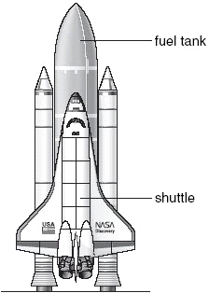

(a) The shuttle has a separate fuel tank containing liquid hydrogen and liquid oxygen.

Explain why hydrogen and oxygen are transported as liquids rather than as gases.

.........................................................................................................................

.........................................................................................................................

1 mark

(b) Oxygen is needed to burn the fuel in the shuttle’s engines.  
Vehicles on Earth do **not** need a tank containing oxygen.

Why does the shuttle need to have a tank containing oxygen?

.........................................................................................................................

.........................................................................................................................

1 mark

(c) The graph below shows how the upward force and the weight of the shuttle, including fuel, change during the first 20 seconds, after the fuel is ignited.



Why does the total weight of the shuttle **decrease** during the first 20 seconds?

.........................................................................................................................

.........................................................................................................................

1 mark

(d) (i) Look at the graph. At 20 seconds, what is the value of:

the upward force on the shuttle?

............. millions of N

the total weight of the shuttle and fuel?

............. millions of N

1 mark

(ii) At 20 seconds, what is the **resultant** force on the shuttle?

............. millions of N

1 mark

(iii) Use the graph to explain why the shuttle **cannot** take off before 10 seconds.

...............................................................................................................

...............................................................................................................

1 mark

maximum 6 marks