**Energy exam question booklet levels 5-7 (2006-2007)**

**Level 5**

**1.** Luke investigated the heating of water. He predicted that the rise in temperature would depend on the volume of water.  
The diagram shows the apparatus he used.



Luke recorded his results in a table as shown below.

|  |  |  |  |
| --- | --- | --- | --- |
| **beaker** | **volume of water, in cm3** | **temperature at start, in °C** | **temperature after** **2 minutes, in °C** |
| A | 25 | 18 | 30 |
| B | 50 | 18 | 24 |
| C | 75 | 18 | 22 |

(a) Why did Luke need to know the temperature of the water at the beginning and at the end of the experiment?

.....................................................................................................................

.....................................................................................................................

1 mark

(b*)* Did Luke’s results support his prediction? Explain your answer.

.....................................................................................................................

.....................................................................................................................

1 mark

(c) Luke stirred the water during the experiment. How did this make his results more reliable?

.....................................................................................................................

.....................................................................................................................

1 mark

(d) Which of the following statements about the energy transferred to the beakers is correct?  
Tick the correct box.

|  |  |
| --- | --- |
| Much more energy went into beaker ‘A’ because its temperature increased the most. |  |
| The same amount of energy went into all three beakers. |  |
| Beaker ‘C’ received the most energy because there was more water to heat. |  |

1 mark

(e) After a time, all three beakers cooled down to room temperature.  
What happened to the thermal energy in the beakers as they cooled down?

.....................................................................................................................

.....................................................................................................................

1 mark

Maximum 5 marks

**Level 6**

**2.** The drawing below shows a garden water feature. It is solar-powered.

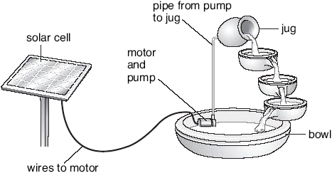

The solar cell absorbs energy from the Sun.  
The solar cell is connected to a motor in the bowl.  
The motor drives a pump.  
Water is pumped up to the jug and it flows back down to the bowl.

(a) Use the information above to help you to complete the following sentences.  
Choose words from the list.



(i) The useful energy change in the solar cell is from  
light to .................................... energy.

1 mark

(ii) The useful energy change in the motor is from  
electrical energy to .................................... energy.

1 mark

(iii) As the water flows from the jug to the bowl ....................................... energy is changed into .................................... energy.

2 marks

(b) Give **one** advantage and **one** disadvantage of using a solar cell to power the water feature.

advantage ...........................................................................................

.............................................................................................................

1 mark

disadvantage .......................................................................................

.............................................................................................................

1 mark

maximum 6 marks

**Level 6**

**3.** The photograph shows some pupils in a log car on a theme-park ride.

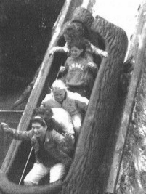

The drawing below shows the ride.  
The letters A, B, C, D, E and F show different points along the track.



The car starts from A and travels to F, where it stops by hitting a bumper.  
At E the car enters a trench filled with water.

(a) (i) At which **two** points does the car have **no** kinetic energy?  
Give the **two** correct letters.

............... and ...............

1 mark

(ii) At which point does the car have the **most** gravitational potential energy?  
Give the correct letter.

...............

1 mark

(iii) At which point does the car have **some** kinetic energy and the **least** gravitational potential energy?  
Give the correct letter.

...............

1 mark

(b) (i) The cars are **not** powered by a motor.  
What force causes the cars to move along the track from B to C?

...........................................................

1 mark

(ii) When a car splashes through the water at E, it slows down.  
What force acts on the car to slow it down?

...........................................................

1 mark

(c) Complete the sentence below by choosing from the following words.



When the car hits the bumper at F, its ................................... energy

is transferred into .............................. energy and

.............................. energy.

3 marks

maximum 8 marks

**Level 7**

**4.** Some pupils investigate whether double glazing or roof insulation is more efficient at reducing heat loss from houses.

They have a model house which can have these features:

• window with single glazing

• window with double glazing

• roof without insulation

• roof with insulation.



(a) A temperature sensor and a small lamp are placed inside the house. The lamp is used as a heat source.  
When the model house reaches a given temperature, **the lamp is switched off**.  
A datalogger then records temperature regularly over time.

(i) What can the combination of single glazing and **no** roof insulation tell pupils that is relevant to their investigation?

...............................................................................................................

...............................................................................................................

1 mark

(ii) Which **two** combinations **must** they use to find the more efficient way of preventing heat loss in their model house?

................................................... and ...................................................

................................................... and ...................................................

1 mark

(b) The pupils predicted that the roof insulation will be more effective than double glazing at reducing heat loss.

What evidence would support this prediction?

.........................................................................................................................

.........................................................................................................................

.........................................................................................................................

1 mark

(c) On the grid below, sketch the shape of the two graphs you would expect to see on the datalogger if the pupils’ prediction is correct.

You do **not** need to add scales to the axes.  
Use a solid line (_____) to show the graph for double glazed windows.  
Use a dotted line (-------) to show the graph for roof insulation.



2 marks

maximum 5 marks

**Level 7**

**5.** Keith has a wind-up radio.  
It does **not** use batteries. It is powered by a steel spring.

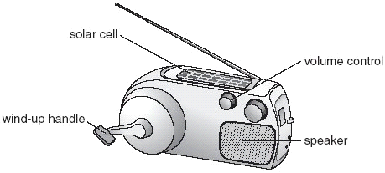

(a) Keith winds up the spring.  
As the spring unwinds, potential energy in the spring is transferred to a generator, which then turns.

The generator provides electrical energy for the radio.

Fill the gaps in the sentences below to show the useful energy changes which take place in the generator and the speaker.

(i) As the generator turns, ............................................................. energy is

changed to electrical energy.

1 mark

(ii) In the speaker, electrical energy is changed to

............................................................. energy.

1 mark

(b) When Keith turns the volume up so that the radio is louder, the spring  
unwinds more quickly.

Why does the spring unwind more quickly?

.........................................................................................................................

.........................................................................................................................

1 mark

(c) The radio has a solar cell which can also provide electrical energy.

Keith winds up his radio and takes it outside without changing the volume.  
The steel spring unwinds more slowly when sunlight falls on the solar cell. Explain why.

.........................................................................................................................

.........................................................................................................................

1 mark

(d) The wind-up radio was designed for use in poorer countries.

Suggest why wind-up radios are useful in poorer countries.

.........................................................................................................................

.........................................................................................................................

1 mark

maximum 5 marks