4.9- 1: Barton’s pendulums

Apparatus

* heavy pendulum bob (e.g. brass or Plasticine, around 0.04 kg is suitable)
* several light pendulum bobs (e.g. Plasticine in small paper cones)
* string
* nylon fishing line or fine string or thread.
* clamp stands with G-clamps
* plastic curtain rings (if you wish to show damping effects)
* slide projector (if desired).

Set up:

Make one driver pendulum with a heavy bob and several light pendulums of various lengths with one length exactly matching the driver. Suspend all the pendulums from a string as below, and support the ends of the string firmly.



The demonstration is most effective in a darkened room with the cones brightly illuminated by a slide projector.

Students look along the line of the pendulums and observe what happens when the paper cones are at rest and then the driver pendulum is released from a widely displaced position.

The effective damping may be reduced by slipping plastic curtain rings over the cones and is easily done if the rings have a single cut in them.

4.9- 2 Forced oscillations

Apparatus

* A computer connected to the internet

What to do

This site contains an applet for a pendulum driven by a sinusoidally varying force:

<http://monet.physik.unibas.ch/~elmer/pendulum/index.html>

Set g= 9.8 N kg-1 and choose a suitable length l.

Predict the natural frequency of the pendulum using the equation you found earlier.



Set the driving frequency to be the same as your predicted natural frequency.

Set the amplitude of the driving force to 0.3.

Set the damping to zero.

Observe the resulting motion of the pendulum.

Use the ‘oscilloscope trace’ to plot a displacement–time graph for the pendulum.

Explore what happens if you alter the driving frequency.

Explore what happens if you increase the damping.

Practical advice

This ‘lab’ gives students further experience in using a spreadsheet to process (simulated) data using log-log graphs, and then goes on to illustrate the effect of the driving frequency and damping on forced oscillations. The first part could arguably be done easily and more authentically using a real pendulum, but the strength of the simulation is that it enables forced oscillations to be explored quantitatively with relative ease.

External reference

This activity is taken from Salters Horners Advanced Physics, section BLD, activity 18

TAP 307- 3: Book on a string

Swing!

High-amplitude oscillations will build up when the driving frequency applied to an oscillator matches the natural frequency of the oscillator. This is a very quick and simple demonstration that shows just that.

You will need

* heavy old textbook
* G clamps, 10 cm jaw
* retort stand, boss and clamp x2
* 1 m lengths of strong string
* drinking straw

Blow by blow

**Pure**

# Maths

**Vol 203**

The book can be made to swing quite dramatically by giving it short blows of air at the correct point of its motion. This is rather like pushing a child on a swing. Get the timing right and the book will move through a considerable angle.

What happens if you blow every second swing?

What happens if a friend blows from the other side in time with the swing?

You have seen

1. That the book will swing through large angles (will have a large amplitude) when the driving frequency matches its natural frequency.

TAP 307- 4: Resonance of a milk bottle

You will need

* audio oscillator or signal generator
* milk bottle or ‘stubby’ beer bottle
* loudspeaker, 50 mm diameter with cut-off filter funnel attached to ‘funnel’ sound

What to do



1. Take a milk bottle or beer bottle and fill it from the tap.

2. If you filled the bottle before reading this line, stop and start again! This time listen carefully to the sound you hear as the water fills the bottle. How would you describe the changes in pitch (or frequency) and loudness as the bottle fills?

3. Put a centimetre or two of water in the bottom of the bottle. Starting with a frequency of about 50 Hz gradually raise the pitch of the speaker whilst pointing the filter cone towards the open neck of the bottle. At a frequency in the range 100 to 400 Hz you will hear the amplitude of the sound rise markedly. At this point the air in the bottle is resonating.

4. Put a little more water into the bottle and find the resonance point again. Repeat this process until the bottle is full.

5. Plot your results (frequency at resonance / height of air in bottle) as you go.

6. Try to explain the observations you made when filling the bottle and listening to the sound in the light of the data.

You have seen

1. When the amount of air in a bottle decreases the resonant frequency goes up.

2. The splashing water must produce notes of many frequencies. The bottle selectively amplifies specific frequencies dependent on the depth of water.

TAP 307- 5: Resonance of a hacksaw blade

When the driving frequency matches the natural frequency of an oscillator the amplitude of oscillation can rise dramatically. This is resonance. This experiment gets you to measure how the amplitude of an oscillating hacksaw blade changes with the frequency of the driver. The hacksaw blade is linked to the vibration generator by a piece of elastic cord. You will see the blade oscillate but will have to decide how to measure the amplitude of oscillation.

You will need

* vibration generator
* signal generator
* 30 cm hacksaw blade
* elastic cord
* slotted base
* G clamps, 10 cm
* leads, 4 mm

Optional:

* stroboscope

Be Safe

|  |  |
| --- | --- |
|  | **Safety**  An oscillating hacksaw blade demands a degree of respect.  Students should wear safety goggles and ensure that the device is well clamped.  If there is a risk of the blade being used as a weapon, have the teeth ground off by workshop staff. |

Setting up

Hz

002.4

string

signal

generator

vibration

generator

hacksaw blade

What to do

Set the variable frequency generator at 1 Hz and measure the amplitude of oscillation. Repeat this at 1 Hz intervals up to 10 Hz. Keep a record of the results – but it is even more vital than usual to plot the results as you go, to see where extra readings are needed to define the curve.

Use the graph plotting package to produce a presentation-quality graph of your results. What do they show you? What happens to the amplitude of the oscillation when the driving frequency matches the natural frequency of the blade?

You have seen

1. That the amplitude of oscillation of the blade increases markedly when the driving frequency matches the natural frequency of the blade.

TAP 307- 6: Resonance of a mass on a spring

When the driving frequency matches the natural frequency of an oscillator the amplitude of oscillation can rise dramatically. This is resonance. This experiment gets you to measure how the amplitude of a mass on a spring varies as the driving frequency is changed.

You will need

* vibration generator
* signal generator
* steel springs
* 50 mm diameter, 250 mm long Perspex tube
* leads, 4 mm
* retort stand, boss and clamps
* mass hangers with slotted masses, 100 g

Setting up

Set the apparatus up:



What to do

1. First of all make a careful estimate of the natural frequency of your mass on a spring and write down this value.

Next attach the mass and spring to the vibration generator and hang it in the Perspex tube. Set the variable-frequency generator at 0.5 Hz and measure the amplitude of oscillation. Repeat this at 0.5 Hz intervals up to 8 Hz. Keep a record of the results – but it is even more vital than usual to plot the results as you go, to see where extra readings are needed to define the curve.

2. Use the graph plotting package to produce a graph of your results. What do they show you? What happens to the amplitude of the oscillation when the driving frequency matches the natural frequency of the mass on the spring?

3. Now repeat the experiment with the mass suspended in water. What differences do you notice?

You have seen

1. That the amplitude of oscillation of the mass increases markedly when the driving frequency matches the natural frequency of the mass on the spring.

2. That the amplitude at resonance is smaller when the oscillation is damped than when it is undamped.

TAP 307- 7: Oscillator energy and resonance

A block of wood of mass 0.25 kg is attached to one end of a spring of constant stiffness

100 N m–1. The block can oscillate horizontally on a frictionless surface, the other end of the spring being fixed.

1. Calculate the maximum elastic potential energy of the system for a horizontal oscillation of amplitude 0.20 m.

2. How does the kinetic energy of the mass relate to the elastic potential energy?

3. Calculate the maximum speed of the block.

A punch bag of mass 0.65 kg hanging from the ceiling is struck and swings with a simple harmonic motion. The total mechanical energy of the oscillations is initially 55 J.

4. Calculate the maximum speed of the punch bag.

5. Describe the energy changes as the oscillations of the punch bag die away.

A drilling machine was found to vibrate so much that accurate work could not be done at certain frequencies. An investigation of its behaviour showed that the amplitude of the vibration of the drill *A* was related to the frequency of rotation as follows:

|  |  |
| --- | --- |
| A / 10–2 mm | f  / Hz |
| 0 | 0 |
| 14 | 5 |
| 30 | 8 |
| 44 | 9 |
| 80 | 10 |
| 96 | 11 |
| 24 | 12 |
| 8 | 13 |
| 2 | 15 |
| 3 | 20 |
| 9 | 25 |
| 7 | 30 |
| 4 | 35 |

6. Draw a graph of *A* against *f* and explain its shape.

7. Why is it advisable to start to drill a hole with the drill rotating at a frequency of between 15 Hz and 20 Hz?

A bumble bee could not fly if its wing muscles had to oscillate at the same rate as its wing beat. Biochemistry makes it impossible for muscles to contract and relax as fast as this. However, the bee avoids the problem by having its wing roots embedded in a special block of elastic material.

8. Thinking of the wing as a mass and the block of material as a spring, explain how the bee’s muscle can beat at a frequency less than the wing beat.

TAP 307- 8: Resonance in car suspension systems

The background

At a simple level a car suspension system can be thought of as a mass-spring system. This means that there will be a ‘natural frequency’ at which the system will oscillate.

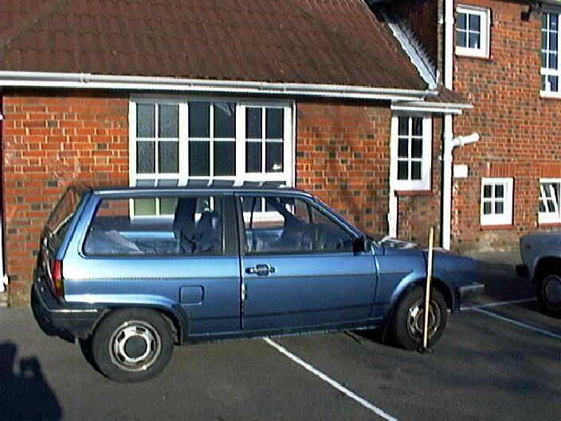

The spring constant

In order to work out the natural frequency of the car we need to know the spring constant of the suspension system and the mass of the car.

The frequency can then be calculated using:



1. By looking at the following sequence of photos of a car, estimate the spring constant, *k*, of the front spring on this car. The weight applied to one side of the bonnet of the car is around 750 N. Below: Front wheel arch of car with no extra weight on the bonnet:

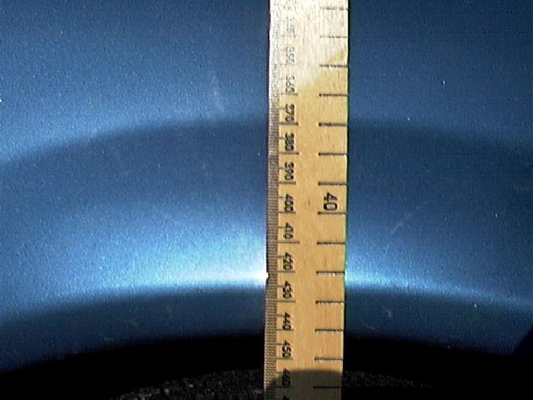

Front wheel arch of car with author sitting on the wing of the bonnet:

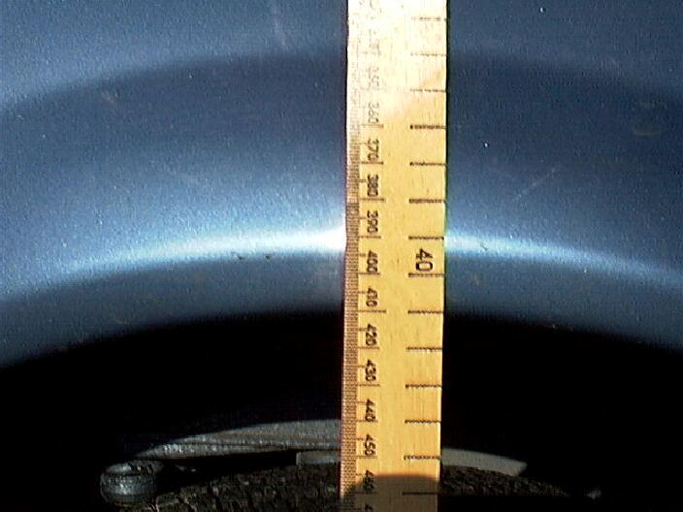

The natural frequency

2. The mass of the car is listed in the handbook as 1120 kg. Calculate the natural frequency of the car suspension. (Remember that a car has four springs in the suspension system and therefore we can assume that the car’s mass of 1120 kg is shared equally between the four springs.)

3. If the car was ‘boxed in’ by other parked cars, describe how this information could be used to allow the car’s owner (and a few friends) to extract the car from its tight location.

Some consequences

4. Whilst driving along a particularly undulating stretch of road the driver noticed that at a speed of 70 km h–1 the car bounced up and down dramatically as it went over the humps.

Calculate how far apart the undulations in the road are likely to have been, if the effect noticed was due to resonance of the car suspension system.

You might like to try a similar calculation for your own car and then try setting it into oscillation and see if the resonant frequency coincides with the calculated value.

TAP 307- 9: Car suspension

The axles and wheels of a car are attached to the car body by a spring suspension system in order to give the passengers a smooth ride. As the car travels over bumps in the road, the wheels follow the road surface up and down, but the much more massive car body moves more-or-less horizontally. The motion of the car wheel and axle therefore approximates to that of an oscillating mass suspended by a spring from a fixed support (the car body).

1.

(a) If you sit over the wheel-arch of a car, your weight depresses the suspension. Assuming that the suspension obeys Hooke’s law, estimate its stiffness, k. Show any other quantities you estimate or calculate in order to arrive at a value for k.

(b) If the spring suspension from (a) is used to suspend a wheel and axle whose combined effective mass is *m* = 100kg, what would be the approximate natural frequency of oscillation of the wheel-plus-axle?

(c) The car wheel-plus-axle system is forced to oscillate as the car goes along a bumpy road. If the bumps become closer together, or the car travels faster, the frequency of these oscillations increases. On the axes below, sketch graphs to show how the amplitude of the oscillations changes as the driving frequency changes in the case where



(i) there is little damping of the suspension and

(ii) when the suspension is heavily damped.

(d) Comment on whether the suspension system of a car should lightly or heavily damped if the aim is to give passengers a smooth ride.

TAP 307- 11: Tacoma Narrows Bridge

Text to read

Engineers need to take oscillations and resonances into account when building bridges. This reading indicates what can go wrong if the static forces on a structure are accounted for, but the dynamic forces are ignored.

Tacoma Narrows

On 1 July 1940, a new bridge was opened up at the narrowest point in Puget Sound, connecting Tacoma, Washington to the Olympic Peninsula. At the time it was the third longest suspension bridge in the world. Right from the beginning, even before the construction was completed, the bridge behaved in a peculiar way. Whenever there was a slight breeze, ripples would run along the bridge. After a while local people began calling the bridge affectionately by the name Galloping Gertie. Driving across the bridge on a windy day became a favourite local pastime because it was like riding a roller coaster, although it was disconcerting to people driving across the bridge to see the car in front of them disappear over the crest of a wave.

Four months after the bridge was opened, on 7 November 1940, a new mode of oscillations showed up in the bridge in a prevailing south-westerly wind of about 42 mph. Instead of rippling motions down the bridge, twisting motions set in. The peculiarities of the bridge were being studied by a hydrodynamicist from the University of Washington, Bert Farquharson. He rushed down to take pictures of the new mode of oscillations. At 11 o'clock in the morning that day, the Tacoma Narrows Bridge collapsed. An inquest into the collapse determined that the bridge had been built according to the best engineering standards of the day. No-one was guilty of wrongdoing, but also no-one could figure out why the bridge collapsed.

A national commission investigating the collapse included Hungarian aerodynamicist Theodore von Kármán of Caltech. He explained that vortices were pouring out of the top and bottom of the deck of the bridge, driving the bridge at its resonant frequency, which eventually led to its collapse. His explanation was confirmed by experiments conducted in wind tunnels with structural models both at the University of Washington and at Caltech. In spite of the confirmation, the bridge-building community was very reluctant to accept the explanation. Why? Bridge architects were concerned with static forces. They built in brute strength to confront maximum load, water flow, wind, etc. They didn’t consider the dynamic forces. Von Kármán said that the shape the roadway presented to the wind acted like an airplane wing. The displaced air formed vortices whose action induced vibrations in the deck. Since that disastrous event, models for all major bridges have been tested in wind tunnels, and bridge engineers have been forced to consider the aerodynamics of their designs.

In the twisting mode, the centre line hardly moves at all – the vibrations go all around it.

The car belongs to a man called Leonard Coatsworth, who was a reporter on a local newspaper; he was the last person to try to cross the bridge. Farquharson himself tried to rescue a cocker spaniel from Coatsworth’s car. For his trouble, he was rewarded by the dog biting him on the hand, which was the only injury in the incident; the cocker spaniel, which never left the car, was the only fatality. A local college student named Winfield Brown decided to walk across the bridge that morning; it was a popular sport on a windy day. He came off crawling on his hands and knees, and reported one moment of sheer terror when the bridge had tilted so much under him that he looked straight down 200 ft into Puget Sound.

At the same spot there is now a new suspension bridge built with modifications suggested by von Kármán. The principal changes were to make the bridge four lanes wide, to use open side trusses, and to place ventilating grills between lanes to equalise wind pressures above and below the deck. The bridge has never had the slightest difficulty. People still look at it nervously on windy days, but it never budges.

Here are some stages in the collapse of the Tacoma Narrows Bridge on that fateful day.

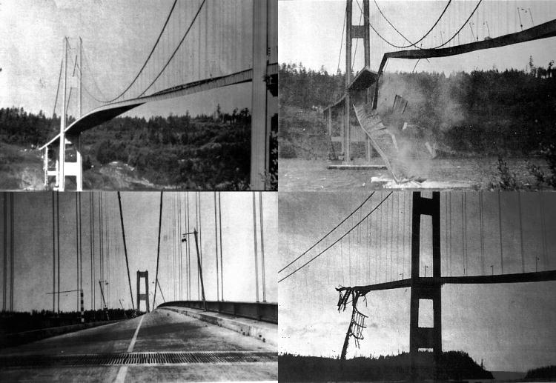

Further pictures and a short video clip are available at:

<http://www.enm.bris.ac.uk/research/nonlinear/tacoma/tacoma.html#file>

TAP 307- 12: Tacoma Narrows: re - evaluating the evidence:

Text to read

This reading is adapted from ‘The collapse of the Tacoma Narrows bridge, evaluation of competing theories of its demise and the effects of the disaster on succeeding bridge designs’ by James Koughan of the Department of Mechanical Engineering, University of Texas at Austin.

It takes further the analysis of what has become a classic example of resonance, found in almost every physics textbook. As recent reinterpretations show, the cause of this famous collapse remains a live controversy in the world of civil engineering.

The facts of the matter

The dramatic end to the Tacoma Narrows Bridge, Washington, has been a standard example of resonance used by teachers and book writers almost since the day it collapsed. Before challenging what has become accepted theory, what are the facts behind this most famous of disasters?

The Tacoma Narrows Bridge was the third longest suspension bridge in the world when it was opened in 1940. It was not a radically new design, but incorporated ideas of bridge design that had been developed over the previous ten years. The central span was 853 metres long and only 12 metres wide between the cable stays. A new method of calculating stresses (known as ‘deflection theory’) was used which allowed lighter, less expensive designs. Shallow plate girders were used on the decking instead of more traditional deep, stiffening trusses. The cables that supported the deck were attached to flexible towers which were more able to deal with changing loads than earlier designs using massive towers. All in all, the design was light, flexible and used the latest technology available.

This extreme flexibility proved to be the weakness in the design of the bridge. The vertical oscillations of the deck began soon after construction. The motion was generally considered fairly harmless and became a draw, as people came to ride the bridge. It was affectionately dubbed ‘Galloping Gertie’ as a result. On the 7 November 1940, some four months after the bridge was built, the vertical oscillations became so large that a supporting cable at mid-span snapped. The unbalanced loading created severe torsional oscillation which led to the collapse of the bridge.

The enquiry that followed the collapse decreed that the design of the bridge had been acceptable, apart from the width to length ratio. It was proposed that a replacement should be wider, despite the additional costs that would be incurred. All experts agreed that the transition from a (relatively) safe vertical motion to the destructive twisting motion was due to the slipping of a cable band to which the centre cable stays were attached. The torsional motions caused the concrete roadway to crack apart. The ‘deflection theory’ had to be addressed further with a view to examining loadings under different and dynamic as well as static conditions.

Why did the bridge collapse?

(i) The standard solution

The source of the motion of the bridge was always known to be the wind. The building up of the oscillations is seen as being due to resonance. In order for the bridge to undergo resonance, there must be a force causing the bridge to move which is periodic, regular and which matches the natural frequency of oscillation of the bridge. This effectively means that any thoughts of gusting winds being responsible can be disregarded. The gusts would have had to be very regular and this phenomenon, apart from being unlikely, was not witnessed.

The long standing theory behind the collapse of the bridge was proposed by the leading aeronautical engineer Theodore von Kármán, who was on the committee set up to study the disaster. He was convinced that the oscillations were due to the shedding of vortices from the bridge. As air flows round an object, swirls of air, called vortices, are carried away by the wind. This is due to air at different speeds combining. Consider a car with the wheels on one side driving faster than the other. The result would be the car would turn with the faster wheels on the outside of the ‘bend’. It is a common and recognised phenomena that with non-streamlined objects the vortices are shed from one side, then the other of the object (see below).

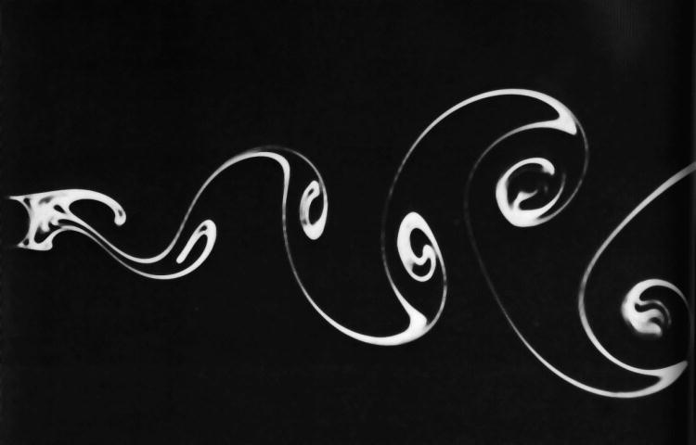

The vortices generate alternating high and low-pressure regions on the downwind side of the body, in this case the bridge. Such vortices are called Strouhal vortices and are shed at a rate determined by the equation



where fs is the frequency of vortex shedding, S is the Strouhal number (a constant for a given body shape), U is the velocity of the air flow and D is a characteristic dimension of the body (usually the width).

The characteristic dimension of the bridge was the thickness of the deck, which was 2.44 m. On the day of the collapse the wind speed was 68 km h–1 which, with an appropriate Strouhal number (developed by wind tunnel testing of many shapes over many years) gives a shedding frequency of about 1 Hz. A secondary effect would also have developed whereby the motion of the bridge would in turn generate vortices which would therefore be shed in time with the oscillations. This phenomenon is called ‘lock on’. This is the generally accepted view of how the bridge came to shake itself to pieces.

However, two researchers by the names of Scanlan and Billah pointed out in 1991 that, as the amplitude of the motion of the bridge built up, other changes to the airflow over the bridge would produce compensating, self-limiting forces. In addition, the twisting motion that, it is accepted, caused the bridge to collapse was at a frequency of around 0.2 Hz. Therefore, the collapse cannot be wholly attributed to the natural vortex shedding of the bridge structure.

Why did the bridge collapse?

(ii) New ideas

Robert Scanlan of Johns Hopkins University believes that the forces that caused the collapse were highly interactive. He claimed, in 1991, that the driving force for the oscillations was not just a function of time, as would be the case with simple vortex shedding, but was also a function of bridge angle during the oscillation. This leads to a phenomenon known as self-excitation.

According to this theory, the motion of the bridge built up to destructive amplitudes based on an intimate interaction of the wind and the structure – the wind supplying the power needed for movement and the movement supplying the power-tapping mechanism. Simply, the twisting of the bridge caused the shedding of vortices which cannot be predicted using the earlier method (the Strouhal frequency). The new flow pattern further excites the torsional mode of oscillation. The aerodynamic forces cannot affect the basic response frequencies of a massive structure like a bridge, but they can affect the damping. This resulted in the increasing amplitudes and the final destruction of the bridge.

Conclusion

As an example of resonance, the destruction of the Tacoma Narrows Bridge remains a firm favourite with educators and hopefully students at all levels. What recent studies show is that the motion of the bridge cannot be simply explained like a resonance experiment in a school laboratory. The interactions of forces, especially in a dynamic situation, become a great deal more complex. It was this that was not foreseen by the designers of the bridge in their use of new methods for lighter, flexible bridge design. However, the fact that it has been some 50 years until a more convincing theory as to the destruction of the bridge has been developed goes some way to exonerating the original designers and gives plenty of food for thought for bridge designers in the future.